DECISION-DELIVERY INTERVAL AND ASSOCIATED FETOMATERNAL OUTCOMES WITHIN 24 HOURS POST EMERGENCY CAESARIAN DELIVERY AT MOI TEACHING & REFERRAL HOSPITAL.

BY
MICHAEL LEWENEI BYEGON
SM/PGRH/04/12

A THESIS SUBMITTED TO THE SCHOOL OF MEDICINE IN PARTIAL FULFILLMENT FOR THE REQUIREMENTS FOR THE AWARD OF THE DEGREE OF MASTER OF MEDICINE IN REPRODUCTIVE HEALTH, MOI UNIVERSITY

©2017

DECLARATION
Student Declaration
This thesis is my original work and has not been presented for an award of a degree or any academic credit. No part of this proposal may be reproduced without prior written permission of the author and or Moi University.

Dr. Michael Lewenei Byegon
Reg. No. SM/PGRH/04/12
Registrar, Department of Reproductive Health
Moi University
Sign……………………………..........................Date ………................………………….

Declaration by supervisors

This thesis has been submitted with our approval as university supervisors
Dr. Philiph Tonui
Lecturer, Department of Reproductive Health
Moi University, School of Medicine

Sign…………………………….............................Date………........................……………

Dr. Pallavi Mishra
Senior lecturer, Department of Reproductive Health
Moi University, School of Medicine

Sign............................…………………………….Date........................................................

DEDICATION

I dedicate this work to all clinicians who have dedicated their lives to improving the outcomes of emergency obstetric and gynecologic procedures.

OPERATIONAL DEFINITION OF TERMS

These terms are defined with emphasis to the meaning implied in this study
Laparatomy: an incision through the anterior abdominal wall into the peritoneal cavity
Hysterotomy: an incision through the uterine wall into the uterine cavity
Best practices at cesarean delivery: these are interventions and practices for which there is current evidence that they lead to optimal outcomes for both the mother and the baby and are therefore recommended as part of standard practice.
Cesarean Section / Cesarean Delivery: delivery of a fetus at or beyond viability together with the placenta and membranes through laparatomy and hysterotomy.
Cesarean Section Rate: the percentage of all live births delivered by cesarean delivery
Decision to Delivery Interval: the length of time it takes between the decision to deliver
a mother via cesarean section and the actual delivery of the infant.
Emergency Cesarean Delivery: cesarean delivery done due to either an immediate threat to the mother, the fetus or both.
Partogram: The graphical representation of labour progress, events and interventions including delivery.
Prophylactic Antibiotics - antibiotics prescribed to be given pre-operatively with the aim of preventing post-operative infection.
Obstructed Labor: labor where there is little or no progress in spite of good uterine contractions

ABBREVIATIONS OF TERMS

ACOG American Congress of Obstetricians and Gynaecologists
APGAR Appearance, Pulse, Grimace, Activity and Respiration
AVD Assisted Vaginal Delivery
CPD Cephalopelvic disproportion
CPR Cardiopulmonary Resuscitation
CS Cesarean Section
CSD Caesarean Section Delivery
CTG Cardiotocogram
DDI Decision to Delivery Interval
DIC. Disseminated Intravascular Coagulation
ECD Emergency Cesarean Delivery
ECS Emergency Cesarean Section
ECV External Cephalic Version
FBS Fetal Blood Sampling
FHR Fetal Heart Rate
FSB. Fresh Still Birth
HIV Human Immunodeficiency virus
HSV Herpes Simplex Virus
IOL Induction Of Labor
IREC Institutional Research and Ethics Committee
KDHS Kenya Demographic Health Survey
KNH Kenyatta National Hospital
LUSCS Low Uterine Segment Caesarean Section
MSB Macerated Stillbirth
MTRH Moi Teaching and Referral Hospital
NRFS Non-Reassuring Fetal Status
PCS Previous Cesarean Section
PIH Pregnancy Induced Hypertension
PMCS Post-mortem Cesarean Section
PPH Postpartum Hemorrhage
PRMCS Peri-Mortem Cesarean Section
RCOG Royal College of Obstetricians and Gynecologist
RMBH Riley's Mother & Baby Hospital
SOGC Society of Obstetricians and Gynaecologists of Canada
SUMI Sub-Umbilical Midline Incision
SVD Spontaneous Vertex Delivery
TOLAC Trial of Labour After Cesarean Section
VBAC Vaginal Birth After Cesarean Section
WHO World Health Organization

ACKNOWLEDGEMENT

I would like to thank my supervisors Drs. Philiph Tonui and Pallavi Mishra for their guidance and support during the development of this thesis.

Decision-Delivery Interval and Associated Feto-maternal Outcomes within 24 hours Post Emergency Caesarean Delivery at Moi Teaching and Referral Hospital, Eldoret

Abstract
Background: Emergency cesarean delivery is done for optimal outcome when vaginal delivery poses a threat to either the mother, fetus or both. American and European obstetric guidelines recommend that, for fetal compromise in labor, delivery should be accomplished ideally in 30 minutes to minimize negative fetal effects of intrapartum hypoxia which complicates about 1% of labors and results in death in about 0.5 in 1000 pregnancies and cerebral palsy in 1 in 1000 pregnancies. The dilemma is that if intervention leads to a good outcome it may be viewed as unnecessary whereas if it leads to a bad outcome it may be interpreted as too slow or too late.
Objective: To determine the decision to delivery interval and its associated feto-maternal outcomes within 24 hours post-operation at Moi Teaching and Referral Hospital (MTRH).
Methods: This study was conducted in MTRH's Riley's Mother and Baby Hospital (RMBH), a specialized maternity wing with a 17-bed labor ward, a 30-bed antenatal ward and a 35-bed postnatal ward. This was a cross sectional study involving examination of 196 women who underwent emergency CS at RMBH. Relevant data was collected in a structured data collection form, from decision to perform CS to 24 hours following CS, entered into a computer access database and analyzed using statistical computation R. Descriptive data was summarized using measures of central tendencies (median, frequencies). Inferential statistics was presented using odd ratios and tabulated (p-value set at 0.05). The test for association between categorical variables was done using Pearson's Chi Square test while the test for association between categorical and continuous variables was done using the two sample Wilcoxon rank sum test. Data was presented in form of tables and graphs. Findings will be disseminated by publishing in reputable journal and presenting in scientific seminars.
Results: Fetal distress, labor dystocia and malpresentation were the leading indications for category I and II CS at 66.4%. Category I constituted 73 (37.2%) cases while category II constituted 123 (62.8%) cases. The median DDI was 114.0 (IQR: 77.8, 163.5) minutes with a minimum and maximum of 30.0 and 588.0 minutes, respectively. The median duration of decision-theatre time was 67 (IQR: 44, 116.5) minutes, theatre-induction time was 30 ( 20, 38) minutes, induction-skin incision time was 2.0 (IQR: 1, 3) minutes and skin incision-delivery was 4.0 ( IQR: 3, 6) minutes. One (0.5%) CS occurred within 30 minutes, 98 (50%) were accomplished within 120 minutes while 19 (20%) remained undelivered beyond 175 minutes of decision. Fetal outcomes (Admission to newborn unit, neonatal death or fresh stillbirths) had no association with DDI (p=0.35). There was no association between maternal outcomes (PPH, visceral injury, urinary bladder injuries, Sub Total Hysterectomy, uterine rupture, uterine dehiscence, thromboembolism) and DDI (p=0.35).
Conclusion: The median DDI was 114 mins and this is higher compared to AGOG recommendations of 30 minutes. The longest delay was observed between decision-theatre. There was no association between maternal outcomes and DDI (p>0.05). Majority of the infants with good APGAR score were delivered within a shorter DDI. The longest delay was contributed by the delay from decision making to receiving the patient in theatre.
Recommendation: Effort should be made to reduce the time from decision to induction of anesthesia. A study to establish factors influencing decision to delivery intervals is called for.

TABLE OF CONTENT
DECLARATION ii
DEDICATION iii
OPERATIONAL DEFINITION OF TERMS iv
ABBREVIATIONS OF TERMS v
ACKNOWLEDGEMENT vii
Abstract viii
TABLE OF CONTENT ix
LIST OF TABLES xi
LIST OF FIGURES xii
CHAPTER ONE 1
INTRODUCTION 1
1.1 Background Information 1
1.2 Problem Statement 3
1.3 Justification 4
1.4 Research Question 4
1.5 Objectives 4
1.5.1 Main objectives 4
1.5.2 Specific Objectives 4
LITERATURE REVIEW 5
CHAPTER THREE 24
METHODOLOGY 24
3.1 Study Setting 24
3.2 Study Design 24
3.3 Study Population 24
3.4 Sample Size 24
3.5 Sampling Technique 25
3.6 Eligibility Criteria 26
3.6.1 Inclusion Criteria 26
3.6.2 Exclusion Criteria 26
3.7 Data Collection and Management 26
3.7.1 Data collection 26
3.7.2 Data Management 28
3.7.3 Data analysis and Presentation 28
3.8 Ethical Considerations 29
CHAPTER FOUR 30
RESULTS 30
4.1 Statistical Data Analysis 30
CHAPTER FIVE 48
DISCUSSION 48
Limitations 52
CHAPTER SIX 53
CONCLUSION AND RECOMMENDATION 53
6.1 Conclusion 53
6.2 Recommendation: 53
Acknowledgement 54
REFERENCES 55
APPENDICES 62
Appendix I: Consent Form 62
Appendix II: Data Collection Form 64
Appendix III: What has to be done between decision to deliver and delivery 69
Appendix IV: RCOG Good Practice Guideline 72
Appendix V: Timelines 73
Appendix VI: Budget 74
Appendix VII: MTRH Approval 75
Appendix VIII: IREC Approval 75

LIST OF TABLES
Table 1. AGAR SCORE CRITERIA 22
Table 2: Socio-demographic Characteristics 30
Table 3: Parity, gravida and ANC profile 34
Table 4: Clinical indications for CSD 35
Table 5: Surgical Personnel 37
Table 6: Practices During Cesarean Section 37
Table 7: Breakdown of DDI 40
Table 8: DDI across the Different Indications 41
Table 9: Maternal Outcomes 42
Table 10: Fetal outcomes 44
Table 11: Association between maternal outcomes and decision to delivery time 45
Table 12: Association between decision to delivery time and fetal outcomes 46

LIST OF FIGURES

Figure 1: Age distribution 31
Figure 2: Distribution by marital status 32
Figure 3: Distribution of participants by occupation 32
Figure 4: Distribution by the level of education 33
Figure 5: Distribution by the nature of admission 33
Figure 6: Distribution by category of indication 36
Figure 7: Distribution of Time from Decision to Delivery 38
Figure 8: Cumulative Percentage Deliveries over Time 39
Figure 9: Relationship between 5 minute APGAR score and DDI. 47

CHAPTER ONE

INTRODUCTION

1.1 Background Information
Caesarian section delivery (CSD) is one of the most common surgical procedures performed on women of child-bearing age. Guillimeau was the first to use the term caesarean section in his book on midwifery in 1598 but this name became universal only in the 20th century.
CSD has been part of human culture since ancient times and has been continuously refined by society from an invariably fatal procedure of last resort to a safe and common mode of delivery. Before, when the child’s health and well being was put first, now the mother’s health and cosmetic outlook is considered just as seriously and now it is heavily being considered as elective or first line when it comes to delivery of a child especially in South American countries like Brazil (Milli Gupta, 2008).
ECD is done when vaginal delivery poses a threat to either the mother, fetus or both occasioned by placenta abruptio, bleeding placenta previa, vasa previa, previous CS due to a recurring cause or in presence of an obstetric complication, uterine rupture or dehiscence, acute fetal distress, cord prolapse, cephalopelvic disproportion, failed instrumental delivery, failed induction of labor, failure to progress in labor (arrest of descent and arrest of dilatation), malpresentation in labor (brow, transverse, face with mentum posterior) among others. Common complications of CS include postpartum hemorrhage that may necessitate subtotal hysterectomy, postpartum infection, thromboembolic disease, pelvic organ injury and anesthetic complications.
Now that most maternal deaths occur in the hospital, perimortem cesarean section (PRMCS) is recommended for the delivery of a fetus after 24 weeks from a pregnant woman with cardiac arrest. It is believed that emergent delivery within four minutes of initiation of cardiopulmonary resuscitation (CPR) improves the chances of success of maternal resuscitation and survival and increases the chance of delivering a neurologically intact neonate (Hosam E. Fadel,2011).
Target decision-to-delivery intervals for emergency caesarean section have been debated since the Consensus Conference in Canada in 1985 (Hannah WJ et al., 1986). Royal College of Obstetricians and Gynaecologists (RCOG) now suggests target delivery times of 30 min for Category 1 and 75 minutes for Category 2 emergency caesarean sections (RCOG 2001; Aiste et al., 2011). The components of the decision-to-delivery interval (DDI) include patient and theatre preparation time, anesthetic time and abdominal skin incision to delivery interval time. This standard decision to delivery interval is difficult to achieve in ordinary practice.
A regular audit of the indications for CSD, DDI and practices at cesarean delivery, would therefore form an important tool in assessing quality of obstetric care in a unit such as the RMBH.
This study seeks to estimate the DDI and associated feto-maternal outcomes within 24 hours after cesarean delivery at MTRH.

1.2 Problem Statement
Worldwide CS commands a disproportionate share of global resources and arguably functions as a barrier to universal coverage of necessary health services as it consumes significant financial resources that can limit financial allocation to other areas of health care for instance preventive heath. Delays occur both in getting the patient to theatre and in achieving effective anesthesia, though delivery within 30 minutes is more likely if the patient gets to theatre within 10 minutes (Tufnell et al.,2001).
In various obstetric emergencies requiring cesarean delivery timely intervention is of essence for optimal fetal and maternal outcomes. Transfer from one hospital unit to another for theatre can be distressing for women and anxieties may crop in during the process. The anxiety for the baby may affect the mother-baby relationship in future. This could be exacerbated by the midwives who may develop anxiety out of their interaction with the mother. There is however limited research in our setup supporting timelines in the execution of emergency cesarean deliveries unlike in the western countries. If intervention leads to a good outcome it is viewed as unnecessary; if it leads to a bad outcome it may be interpreted as too slow or too late.

1.3 Justification
CS is a common major surgical obstetric procedure and there is an increasing trend in its indications. CS is one of the procedures of improving feto-maternal outcomes among women with specific indications. Estimating the decision to delivery interval is important in assessing the quality of CS delivery services and contributes in attainment of favorable maternal and fetal outcomes. Such a study has not been done at the Moi Teaching & Referral Hospital maternity. The findings of this study will bring out the association between the DDI and feto-maternal outcomes, highlight specific areas of improvement and also help in the development and evaluation of set CS and related delivery protocols. This will contribute to improvement of quality services and attainment of clients/patient satisfaction.

1.4 Research Question
What is the decision-to-delivery interval and its associated feto-maternal outcomes within 24 hours post cesarean delivery at the MTRH?

1.5 Objectives

1.5.1 Main objectives
To determine the decision to delivery interval and its associated feto-maternal outcomes within 24 hours post operation at the Moi Teaching and Referral Hospital.

1.5.2 Specific Objectives
- To describe the main indications for emergency caesarian deliveries
- To describe the decision to delivery intervals for emergency ceaserian deliveries
- To describe feto-maternal outcomes within 24 hours post operation
- To correlate the decision to delivery interval with indications and immediate feto-maternal outcomes
CHAPTER TWO

LITERATURE REVIEW
DDI is the time it takes from making a decision to deliver by CS to the actual delivery of the infant. Animal models have shown a direct proportionality between the length of pre-delivery asphyxia and the degree of irreversible fetal damage (Adamsons and Myers, 1973). In humans fetal distress demonstrable on a cardiotocogram (CTG) as in cord prolapse, major placental abruptio, uterine rupture and maternal hypoxemia prompted the setting of maximum DDI.
Intrapartum hypoxia complicates about 1% of labours and results in death in about 0.5 in 1000 pregnancies and cerebral palsy in 1 in 1000 pregnancies (Gaffney et al.,1994). When it is diagnosed clinically as “fetal distress” swift delivery is the aim, and the standard has become delivery within 30 minutes of diagnosing fetal distress (James D. 2001).
The pathogenesis of intrapartum hypoxia is often multifactorial but poorly understood. Processes such as uteroplacental vascular disease, reduced uterine perfusion, fetal sepsis, reduced fetal reserves, and cord compression can be involved alone or in combination, and gestational and antepartum factors can modify the few l response (Murphy etc al., 1995). Methods of screening and diagnosing the condition have limitations (Thaler etc al., 2001).
For reasons which are not clear, logical, or evidence based, this audit standard of 30 minutes has become the criterion by which good and bad practice is being defined both professionally and medicolegally. The implication is that caesarean section for fetal distress that takes longer than 30 minutes represents suboptimal or even negligent care. Yet the evidence that 30 minutes represents a clinically important threshold is lacking both in theory and in clinical experience.
In theory, the speed with which hypoxia develops and the ability of the fetus to withstand this insult vary and are difficult to quantify. Sudden and profound hypoxia such as occurs with placental abruption or vasa praevia probably requires delivery within 10 minutes if death or serious disability is to be avoided. In contrast, if the hypoxic insult is more slowly progressive in non reassuring CTG and delivery within 30 to 60 minutes is unlikely to result in serious harm. In such cases the usual threshold for intervention is a fetal scalp pH of <7.20, yet serious neurodevelopmental disability probably occurs only when the pH is <7.00 (Van den Berg e.g. al., 1996).
The audit of 126 caesarean sections for fetal distress by MacKenzie et al and104 caesarean sections for fetal distress by Dunphy et al found no correlation between DDI and several outcome measures, including umbilical arterial acid-base state and 5 minute Apgar scores. Tufnell et al did not show any significant relation between DDI and admission to a neonatal unit. Moreover, Chauhan et al, reporting an audit of 117 caesarean sections for fetal distress found that those cases with a decision to incision (not delivery) interval of less than 30 minutes had significantly lower mean umbilical artery pH values and a higher incidence of cases with pH <7.00.
MacKenzie et al., and Okunwoobi et al., observed that all cases (not just those for fetal distress) delivered by caesarean section within 30 minutes were associated with significantly lower umbilical artery pH values. They speculated that this could have been a result of maternal anxiety raising circulating catecholamine levels hence reducing uterine perfusion. However, it also likely that those delivered very fast would include crash emergencies with more acute hypoxia, such as placental abruption and profound fetal bradycardia where fetal compromise was already well established or would evolve very fast.
In most countries including the USA and Canada the recommended DDI is 30 minutes while German DDI is 20 minutes (MacKenzie et al., 1995). Royal College of Obstetricians and Gynaecologists (RCOG) now suggests target delivery times of 30 min for Category 1 and 75 min for Category 2 emergency caesarean sections (RCOG 2001; Aiste, et al., 2011). Delays occur both in moving the patient to theatre and in the anesthetic process though delivery is achievable within 30 minutes if the mother is received in theatre within 10 minutes (Derek, et al, 2001. Agitation that may result from the attempt to expedite this process can be distressing for the mother and may raise anxiety or even affect bonding between mother and newborn posing a threat to their relationship in the long term.
The recommended DDI is difficult to achieve in routine practice yet various studies have yielded contrasting results on perinatal outcomes versus the DDI. Failure to meet the recommendations does not seem to increase neonatal morbidity (Derek, et al, 2001). The main reason for urgent delivery is the presumption that it is important for fetal well-being. This presents the classic dilemma for obstetricians and pediatricians: If intervention leads to a good outcome it is viewed as unnecessary; if it leads to a bad outcome it may be interpreted as too slow or too late. When medicolegal experts review cases retrospectively, knowing the outcome for the baby, then the interval between decision and delivery is certain to be examined and if the arbitrary DDI standard is used then it may well be that a considerable number of cases will be judged to have received “unreasonable” care. It is probably more appropriate to consider what proportion of cases will be delivered within a particular time from the decision to deliver in a real, day to day situation (Derek, et al., 2001).
Moreover, the 30-minute goal poses major challenges to the nursing, anesthesia, and surgical teams that provide care to morbidly obese women who require emergent cesarean delivery. Nevertheless, efforts to reduce this interval are vital, preferably in four phases:
- the time it takes to move the mother to the operating room
- the time it takes to position the mother on the operating table
- the time taken to administer anesthesia
- the time it takes from skin incision to delivery of the fetus.
Because all four phases will be prolonged in morbidly obese patients, it is prudent for obstetric units to develop protocols to identify and flag women who are at risk, and to have policies and procedures in place to reduce these times. This may necessitate drills for rehearsal and testing of response times and skills of the various providers. In addition, whenever emergent cesarean section delivery is performed, the actual response time and effectiveness of interventions should be evaluated (Tufnell et al 2001, Dwyer JP 1999, Lucas DN 2010).
RCOG has categorized Cesarean Sections into four :
Category I (Emergency): Immediate threat to life of woman or fetus
Indications include:
- Acute fetal distress/Fetal bradycardia
- Cord prolapse
- Severe placenta abruptio
- Bleeding placenta previa major with maternal hypovolemia
- Vasa previa
- Uterine rupture and scar dehiscence
- Failed instrumental delivery with fetal distress
The DDI in category I should be within 30 minutes.
Although several national bodies recommend a decision-to-incision or delivery interval of 30 minutes or less, this approach is not backed by definitive data. This is especially true in cases that involve catastrophic events, such as abruptio placentae, cord prolapse, uterine rupture, or vasa previa—where minutes matter.
Category II (Urgent): Maternal or fetal compromise but not immediately life threatening
Indications include:
- Malpresentation in labor e.g. Brow presentation, face mentum posterior
- Antepartum hemorrhage without hypovolemia
- Failed IOL
This category of indications for emergency CSD is often riddled with dilemma in making the decision to intervene.
A partogram is very useful in documenting and hence recognition of slow progress of labor and fetal distress.
Category III (Scheduled): Needing early delivery but no maternal or fetal compromise
Indications include:
- Early labor in woman booked for elective LUSCS
- Macrosomic baby in early labor
- Breech in early labor
Category IV (Elective): At a time to suit the woman and maternity team
Indications include:
- Previous LUSCS X 2
- Refused TOLAC
- Breech presentation at term
- Multiple pregnancy at term
- HIV and HSV infection
- Maternal request
Greg, et al., 2011 carried out a prospective observational cohort study in a teaching hospital providing district and tertiary maternity services delivering 6000 babies per annum and concluded that 68% Category 1 deliveries were achieved within 30min and 66% Category 2 within 75min. Category 1 deliveries were quicker using general rather than regional anaesthesia (Greg et al. 2011).
The 30 minute DDI remains difficult to achieve in many obstetric units (Elvedi-Gasparovic et al., 2006; Onah, et al., 2005). The availability of the theatre staff within the hospital enhances shortening of DDI as opposed to assembling the team by calling from home (Onah, et al., 2005). Developing standard operating procedure for a maternity and crash cesarean section drills appears to greatly reduce the average DDI hence improving perinatal outcome (Lim et al. 2005; Visnja, 2013).
Whereas patient safety is of paramount importance and a priority, there are justified concerns in crash cesarean deliveries stemming from anesthetic complications like failed or delayed intubation, aspiration and hypoxemia from vomiting where rapid induction favors general anaesthesia yet patients for emergency procedures are rarely starved (Robert, 2006). In instances of major placental abruptio disseminated intravascular coagulation (DIC) may occur yet adequate preparation for massive transfusion may not have been done. This would lead to maternal hemorrhage further risking the life of the mother (Hillemanns, 2003).
Other crash cesarean deliveries have yielded fresh stillbirths (FSB) or even macerated stillbirths (MSB) where haste in taking fetal heart rate may have resulted in misinterpretation of maternal as fetal heart rate. This can be devastating for both healthcare providers and patients and her family (Hillemanns, 2003).
Use of a partogram with a 4 hr action line if well kept and action line observed is a proven tool in reducing the likelihood of a CSD, expedites delivery, as well as improves perinatal outcome (Lavender, et al., 2009).
A consultant obstetrician should be contacted to confirm a decision for any cesarean section and should be present for at least 10% of the potentially complicated cesarean deliveries (Thomas, 2001). A decision to delivery interval of thirty minutes is recommended as the gold standard for emergency CD even though it is riddled with controversy (MacKenzie et al., 2001; Lucas, 2010).
Antibiotic prophylaxis in women undergoing caesarean section leads to a decreased risk of infection-related complications, including fever, endometritis, wound infection, urinary tract infection, and serious infection after caesarean section; a small reduction was also found in the mother's duration of stay in hospital (Alan T.N. Tita et al,2009). Ampicillin and first generation cephalosporins show similar effectiveness and there seems to be no justification for using any other drug with a broader spectrum or multiple drugs (Cecatti, 2005). Current guidelines recommend that antibiotics should be given right after the clamping of the umbilical cord to prevent these medications from entering the fetal blood circulation (Armin et al., 2011).
Majority of CSs should be performed under regional block. It is safer and has less neonatal and maternal morbidity even for women with placenta previa. Neuraxial anesthesia for cesarean delivery is preferred to general anesthesia because it minimizes the risk of failed intubation, ventilation and aspiration (Mark et al., 2011).
Two lower abdominal (Pfannenstiel and Joel-Cohen) and one midline vertical skin incisions have been used in abdominal deliveries. Historically, a vertical midline skin (sub-umbilical midline) incision (SUMI) was preferred for less hemorrhage and speed of delivery. However, it is less cosmetic. SUMI can easily be extended around and above the umbilicus if better exposure is desirable. When making a vertical incision, it is important to remember that the linea nigra may not necessarily lie in the true midline (Storyl and Paterson-brown, 2009).
Transverse incisions follow natural creases of the anterior abdominal therefore are cosmetically appealing and are under less tension hence are associated with less postoperative pain. Pfannenstiel incision is the most frequently used and is made transversely in the maternal abdomen approximately 2–3 cm above the symphysis pubis and is curvilinear, with the lateral apices of the incision smiling up toward the anterior superior iliac spines. After the fascia is incised, the anterior rectus fascia can then be dissected from the underlying rectus muscles in both the cephalic and (if needed) caudal directions by a combination of blunt and sharp dissection. The peritoneal incision is extended either bluntly or using scissors, to maximize surgical exposure.( Storyl and Paterson-brown, 2009).
The Joel-Cohen incision is performed in a transverse manner 2-3cm above and cephalad to the location of a Pfannenstiel incision and is linear, not curvilinear or 3 cm below a straight line joining the anterior-superior iliac spines. Once the fascia is incised the rest of the dissection is performed bluntly. Hypertrophic scars are best excised as this gives a better cosmetic result and is associated with faster suturing and improved wound healing (Osama Naji et al.,2010)
Transverse skin incision of choice should be the Joel Cohen, it has been associated with shorter operating time and reduced incidence of postoperative febrile morbidity, Pfannenstiel incisions may also be used but they take longer to enter the peritoneal cavity.
Use blunt, not sharp, expansion of the uterine incision. In a prospective, randomized trial blunt expansion was associated with lower estimated blood loss (375 ± 95 mL vs 443 ± 86 mL; P <.05). These findings reveal that blunt expansion of the uterine incision in primiparas is safer and easier than sharp expansion (Sekhavat, et al., 2010).
There are three standard uterine incisions that can be performed for delivery of the fetus: low transverse, low vertical, and classical. The specific type of uterine incision should be determined by the primary surgeon at the time of the operation based on gestational age and lie of the fetus and any uterine anomalies (Storyl and Paterson-brown, 2009).
It is recommended to close the peritoneum. Non-closure after cesarean delivery is associated with a higher rate of adhesion formation (Sekhavat, et al., 2010). A systematic review and meta-analysis that included two randomized trials and one prospective study compared the rate of adhesions after cesarean delivery between women who had peritoneal closure (n = 110) and those who did not (n = 139). Non-closure was associated with a substantial increase in the rate of subsequent adhesion formation (adjusted odds ratio, 4.23; 95% CI, 2.06–8.69) (Cheong, et al., 2009; Shi, et al., 2011). Adhered to, these practices at cesarean section improve the outcome of the operation.
A proper diagnosis is a prerequisite. A record should be made of all the factors that influence the decision, and which of these is most influential. Suboptimal indications should be reviewed.
Fetal distress, synonymous with non-reassuring fetal status (NRFS) is the term commonly used to describe fetal hypoxia. Its a clinical diagnosis, and may be defined as hypoxia that may result in fetal damage or fetal death if not reversed or the fetus delivered immediately.
Maternal etiology of fetal distress:
- Microvascular ischaemia (pregnancy induced hypertension-PIH)/poor placental perfusion
- Low oxygen carried by RBCs(severe anaemia)
- Antepartum hemorrhage-APH (placenta previa, placenta abruptio, vasa previa)
- Shock/hypovolemia
- Hypotension (aortocaval compression, epidural anaesthesia)
- Acute infection
- Myometrial hypertonus (prolonged labor, excess oxytocin)
Placental and umbilical etiological factors:
- Placental insufficiency
- Cord compression (oligohydramnios, entanglement, prolapse)
Fetal etiology:
- Cardiovascular malformations
- Intrauterine infection
- Preexisting hypoxia or growth retardation
An abnormal CTG in the diagnosis of NRFS would have one or more of the following:
- Persistent severe variable decelerations
- Persistent and non-remediable late decelerations
- Persistent severe bradycardia
An abnormal fetal heart rate (FHR) shown by electronic fetal monitoring indicates suspected fetal acidosis, however fetal blood sampling (FBS) will provide a reliable diagnostic tool to prove or disprove the case. Fetal scalp blood sampling should not be performed if there is clear evidence of serious fetal compromise or if there are any contraindications of performing FBS. Once fetal blood sampling (FBS) has given a diagnosis of fetal hypoxia, delivery should occur within 30 minutes(Annappa et al 2008)
Contraindications of performing FBS include:
- Clear evidence from continuous electronic fetal monitoring (EFM) of serious continuous fetal compromise
- Potential fetal bleeding disorders e.g. suspected fetal thrombocytopenia , hemophilia
- Prematurity- gestation less than 34 weeks.
- Face presentation
- Maternal infection e.g. HIV, hepatitis, herpes simplex, suspected intrauterine sepsis (Whitworth, et al., 2006; Annappa, et al., 2008; East, et al., 2010)
Delayed delivery due to the procedure may be associated with an increased risk of adverse outcome. A small "at risk" fetus may sustain neurological damage earlier than a term fetus.
Neither elective repeat cesarean delivery nor trial of labor after cesarean section (TOLAC) are without maternal or neonatal risk. The risks of either approach include maternal hemorrhage, infection, operative injury, thromboembolism, hysterectomy, and death. Most maternal morbidity that occurs during TOLAC occurs when repeat cesarean delivery becomes necessary. Thus, vaginal birth after cesarean section (VBAC) is associated with fewer complications, and a failed TOLAC is associated with more complications, than elective repeat cesarean delivery. Most published series of women attempting TOLAC have demonstrated a probability of VBAC of 60–80% (Collea, et al., 1980; Gimovsky, et al., 1983). However, the chance of VBAC for an individual varies based on demographic and obstetric characteristics.
Increased Probability of Success (Strong predictors)
- Prior vaginal birth
- Spontaneous labor
Decreased Probability of Success (Other predictors)
- Increased maternal age
- Non-white ethnicity
- Gestational age greater than 40 weeks
- Maternal obesity
- Short inter-pregnancy interval
- Increased neonatal birthweight (Collea, et al., 1980; Gimovsky, et al., 1983)
Fetal dystocia is abnormal fetal size or position resulting in difficult delivery. Diagnosis is by examination, ultrasonography, or response to augmentation of labor. Treatment is with physical maneuvers to reposition the fetus, operative vaginal delivery, or cesarean delivery.
The aetiology may be remembered as 3 Ps: 'The Powers' (uterus), 'The passenger' (fetus) and 'the passage' (pelvis).
- Uterine factors: good contractions start at the fundus and move down towards the pelvis. If uterine activity is uncoordinated or contractions short or infrequent then labor will be difficult and prolonged. Uterine incoordination is commoner among primigravidas hence they tend to have longer labors. Oxytocin can enhance and coordinate uterine contractions.
- Fetal factors: normal fetal presentation is vertex, with vertex anterior. Position or lie eg breech, macrosomia, shoulder dystocia result in difficult delivery.
- Pelvic passage factors: a gynecoid pelvis with a round brim is very favorable in labor because it has a wide and round sub pubic arch,wide sacrum and the iliac bone is flatter. However some women have a long and oval brim. Other factors that lead to cephalopelvic disproportion are scoliosis, kyphosis and rickets (Draycott et al.,2008).
Cervical dystocia is failure of the cervix to dilate during labor, and can be due to previous cone biopsy or cauterization for cervical dysplasia; trauma; uncoordinated uterine contraction-- this responds to augmentation with oxytocin. If dystocia continues despite this then caesarean delivery is the solution.
Fetopelvic disproportion is suggested by prenatal clinical estimates of pelvic dimensions on physical examination, ultrasonography, and protracted labor. If augmentation of labor restores normal progress and fetal weight is < 5000 g in women without diabetes or < 4500 g in women with diabetes, labor can safely continue. If progress is slower than expected in the second stage of labor, women are evaluated to determine whether operative vaginal delivery (by forceps or vacuum extractor) is safe and appropriate (Draycott et al.,2008).
The most common abnormal presentation is occiput posterior. The fetal neck is usually somewhat deflexed; thus, a larger diameter of the head must pass through the pelvis. Many occiput posterior presentations require operative vaginal delivery or cesarean delivery (Leung et al.,2011).
In face presentation, the head is hyperextended, and position is designated by the position of the chin (mentum). When the chin is posterior, the head is less likely to rotate and less likely to deliver vaginally, necessitating cesarean delivery. Brow presentation usually converts spontaneously to vertex or face presentation (Leung et al.,2011).
The second most common abnormal presentation is breech (breech before the head). Between 3-4% of babies begin labor in breech increasing the risk of neonatal morbidity and mortality (Catherine and Johanne, 2010). There are several types:
Frank breech: The fetal hips are flexed, and the knees extended (pike position).
Complete breech: The fetus seems to be sitting with hips and knees flexed.
Single or double footling presentation: One or both legs are completely extended and present before the buttocks.
Breech presentation is a problem primarily because the presenting part is a poor dilating wedge, which can cause the head, which follows, to be trapped during delivery, often compressing the umbilical cord.
Umbilical cord compression may cause fetal hypoxemia. The fetal head is probably compressing the umbilical cord if the fetal umbilicus is visible at the introitus, particularly in primiparas whose pelvic tissues have not been dilated by previous deliveries.
Predisposing factors for breech presentation include preterm labor, uterine abnormalities, and fetal anomalies (Philippe et al., 2015).
If delivery is vaginal, breech presentation may increase risk of birth trauma, dystocia, and perinatal death.
External cephalic version (ECV) at term is associated with a significant reduction in non-cephalic births and CSD. A meta-analysis and review of RCTs recommends that women with a singleton breech, uncomplicated at 36wks, and not in labour, should be offered ECV. A dose of a short-acting tocolytic (terbutaline 0.25 mg sc) may help some women. The success rate is about 50 to 75%.Those, for whom ECV is contraindicated or has been unsuccessful, should be offered elective CS as it reduces perinatal mortality and neonatal morbidity. Preemptive caesarean section has however been challenged as the preferred method of delivery of breech and vaginal breech delivery is no longer reserved for advanced labor or imminent delivery (Julie S. Moldenhauer, MD, 2016).
ACOG in July 2006, concluded that deciding which mode of delivery to use for a term breech baby should be dependent upon the clinician’s experience. Planned vaginal delivery may be a reasonable option if the choice is based on a specific protocol of care used within a hospital setting, which defines eligibility and management of labor. The patient must be informed that perinatal and neonatal mortality, and short-term severe neonatal morbidity, may be higher. The patient must give informed consent (Catherine and Johanne, 2010).

If fetal position is transverse, with the fetal long axis oblique or perpendicular rather than parallel to the maternal long axis or shoulder-first presentation requires cesarean delivery unless the fetus is a second twin (Catherine and Johanne, 2010).

Generally CSD is a very safe operation and complications that arise are not primarily due to the operation itself but are related to the indication for CSD. It does however pose a higher risk than does vaginal delivery.
The most common complications include aspiration during induction of anesthesia since there is usually minimal time for patient preparation like starving. Nausea, vomiting and headache are also related to the anesthesia while ileus may set in especially where there is extensive handling of bowel. Postpartum hemorrhage occurs where blood loss exceeds 1000 mls.
Uterine, cervical or adjacent organ injury like the bladder, bowel occurs at about 12%. Nielsen and Hokegard noted 18.9% in emergency in comparison to 4.2% in elective CSD (medscape.com).
Post-operative wound sepsis may occur and incidence are lower with the use of prophylactic antibiotics. Thromboembolic events may also occur and should be prevented with the practice of thromboprophylaxis and early ambulation.
These risks increase with each additional CSD and include uterine dehiscence, uterine rupture, placenta previa, placenta accreta, placenta increta, and placenta percreta in subsequent pregnancies that may necessitate hysterectomy (Erin et al.,2011).
Risks to the infant include
- Injury during delivery occurs very rarely. The baby may be nicked or cut during the incision.
- Low APGAR scores: can be a result of anesthesia, fetal distress before delivery or lack of stimulation during delivery. Vaginal birth offers natural stimulation during labor. Babies born by CSD are more likely to have lower APGAR scores than those born vaginally (Gulzar et al.,2007).
- Prematurity in cases of miscalculated dates or delivery before 39 weeks of gestation.
In 1952 Virgin Apgar, an anesthesiologist, proposed her score as a means of assessing the immediate postpartum condition of infants to assess the effects of obstetric anesthesia (Pearce JM 2005). The test is generally done at one and five minutes following delivery and may be repeated at ten, fifteen minutes or later if the score remains poor or maternal condition deteriorates. Low APGAR scores below 3 may be indicative of longer term neurological damage that may increase the risk of cerebral palsy. A good APGAR score doesn’t however guarantee a healthy baby as it doesn’t screen for all possible complications like chromosomal abnormalities.

Table 1. AGAR SCORE CRITERIA
CRITERIA | SCORE
CRITERIA | 0 | 1 | 2
Appearance (A) | Blue or pale all over | Body pink  Blue extremities (acrocyanosis) | Pink body and extremities
Pulse (P) | absent | <100/min | >100/min
Grimace (G) | No response to stimulation | Grimace on suction or aggressive stimulation | Cry on stimulation
Activity (A) | None | Some flexion | Flexed limbs that resist extension
Respiration (R) | Absent | Weak, irregular, gasping | Strong lusty cry

Total APGAR Interpretation
0 to 3: critical and requires immediate attention.
4 to 6: low and infants should be monitored closely.
7 to 10: normal (Pearce JM 2005).
A 2010 study from Norway indicates that 11% of children with critical APGAR scores are diagnosed with cerebral palsy by age 5. This association was higher in normal birth weight compared with low birth weight children (BMJ 2010 Oct 6)
Clinical diagnosis of fetal distress is associated with adverse early neonatal outcome. Geidam et al found out that the cases were more likely to have a 5 minute APGAR score of less than 7 compared with controls. After controlling for confounders they also concluded that CSD for fetal distress based on intermittent auscultation rescue infants with a relative risk reduction of 71% for 5 minute APGAR score <7 and 67% for stillbirth, lending credence to the use of intermittent auscultation especially in low resource settings (Geidam et al.,2009).
Being a national referral hospital, RMBH not only admits patients from within its environs, it also handles referrals from heath facilities in the western part of Kenya some of which are quite far away. In referrals with clear indications for CSD or operative vaginal delivery from facilities that lack personnel or capacity to intervene it is often thought that much delay would affect fetal , maternal or both outcomes and as such this study would exclude such mothers because further delay during transport would affect the outcome. During the period of study only one maternity theatre was available.

CHAPTER THREE

METHODOLOGY

3.1 Study Setting
The study was conducted at Moi Teaching and Referral Hospital (MTRH), Riley Mother and Baby Hospital (RMBH) Antenatal, Postnatal and Labor wards. MTRH, the second largest referral hospital in Kenya, is a 796 bed capacity and serves the western Kenya region. The Rileys Mother & Baby Hospital is a specialized maternity wing of the hospital with a 17 bed labor ward, and a 30 bed antenatal ward, and a 35-bed postnatal ward. In the year 2013 the hospital conducted about 950 deliveries per month. Approximately, 15% of all deliveries were caesarian deliveries and the hospital recorded an average of 4-5 cases of caesarian section deliveries daily, with approximate of 3 emergency caesarian deliveries.

3.2 Study Design
This was a descriptive cross sectional study in which emergency cases of caesarian deliveries were studied and relevant data relating to the decision to delivery interval and immediate feto-maternal outcomes were collected prospectively within 24-hour post-operative period.

3.3 Study Population
The study population comprised of all mothers with medical indications for emergency cesarean delivery at the RMBH.

3.4 Sample Size
In order to be 95% sure that the proportion of mothers receiving ECD among all the women who undergo ECD delivery is within plus or minus 5% of the population proportion of 50% a sample size was estimated using the following formula (Cochran, 1963).
Where
P = is the population proportion of those who undergo category I and II cesarean sections among all the women who undergo CS delivery,
=is the margin of error equal to the 5% used in this case, and
= is the quintile of the standard normal distribution.
Adjusting for finite population size of approximately 400 cesarean section deliveries in the first quarter of the year 2013 gives us;

3.5 Sampling Technique
Mothers at RMBH delivery wards who met the study inclusion criteria was sampled consecutively until the desired sample size was attained. Every mother with emergency medical indication for cesarean section delivery and who was willing to participate and provide informed consent was sampled.

3.6 Eligibility Criteria

3.6.1 Inclusion Criteria
- Expectant mothers with medical indication for category I and II emergency caesarean section delivery
- 18 years and above
- Those who provided an informed consent

3.6.2 Exclusion Criteria
- Category III and IV cesarean deliveries
- Referrals whose decision to perform emergency cesarean delivery or operative vaginal delivery had been made in the referring facility but could not be executed for whatever reason including shortage of staff or theatre supplies.
- Mothers whose decision to deliver and/or cesarean delivery was done by principal investigator.

3.7 Data Collection and Management

3.7.1 Data collection
Clients were recruited and consented once the decision to conduct emergency CSD was made in the labor or antenatal wards. In the situation of a crash emergency where the consenting process could have caused further delay in delivery or when the mother was not in a stable mental condition to offer informed written consent, this was deferred to within 48 hours post operation. Socio-demographic, obstetric characteristics, medical history of the participants, clinical and laboratory data and diagnoses were recorded. Time was recorded at various points using standardized clocks in the antenatal, labor and operating rooms. Time was entered as follow and intervals worked out.
- Decision time: The time when the decision to perform the emergency CSD was made.
- Receiving time: The time when the patient is received in theatre.
- Induction time: The time when the anesthetist starts infiltrating the anesthesia to the patient through the intravenous or spinal access line.
- Skin incision time: The time when the abdominal skin incision is started.
- Delivery time: The time when the baby's head is delivered.
The following intervals were calculated:
Interval 1: Decision to Receiving time = Receiving time minus Decision time (minutes).
Interval 2: Receiving to Induction time = Induction time minus Receiving time (minutes).
Interval 3: Induction to Skin incision time = Skin incision time minus Induction time (minutes).
Interval 4: Skin incision to Delivery time = Delivery time minus Skin incision time (minutes).
Information on feto-maternal outcomes was gathered at any time they occur while the mother had not exceeded 24 hours post operation. Each data collection form (appendix II) was confirmed to be duely filled by 48 hours post operation, and gaps were filled from the patient files, nurses' records, anesthetist charts, operation notes and doctors' notes.

3.7.2 Data Management
Filled data collection forms were entered into an electronic database (SPSS) that was encrypted.
The data were stripped off of identifiers. Data was maintained with strict confidentiality and access restricted only to the principal investigator and the research assistant. After entry the filled data collection forms was kept in safe data cabinets with lock and key. The computer database was protected with a pass-word to restrict access to unauthorized individuals. Filled data collection forms would be destroyed by shredding after publication of study results. Data was then entered into access database and exported to R statistical software for analysis (R Core Team, 2016).
Quality of data was maintained by providing basic research training to research assistants and data manager and parallel data entry was done to ensure accuracy and consistency of data.

3.7.3 Data analysis and Presentation
Data analysis was done using statistical computation R. Categorical variables were summarized as frequencies. Continuous variables that followed normal distribution was summarized as mean. The test for association between categorical variables was conducted using Pearson’s Chi Square test while the test for association between categorical and continuous variables was conducted using the two sample Wilcoxon rank sum test if the continuous variables violated the assumptions of normal distribution. Data was presented in form of tables and graphs.

3.8 Ethical Considerations
Approval was sought and granted by Moi university's institutional research and ethics committee (IREC) before the study commenced. The permission to conduct the study were obtained from the management of Moi Teaching and Referral Hospital. All the participants was notified about the purpose of the study and asked without any coercion, force or pressure to give a signed written informed consent before participating. Data management practices that ensured adequate confidentiality was maintained and these included storing data in key locked cabinets, use of password coded databases and consenting in private consultation room. There was no direct financial benefit or compensation for participating in the study. Sound clinical judgment was involved in all stages and aspects of this research. Mothers whose decision to deliver and/or cesarean delivery were done by principal investigator were excluded. This was to ensure objectivity in measuring DDI.

CHAPTER FOUR

RESULTS

4.1 Statistical Data Analysis
A total of 196 participants were included in the study. The median (IQR) age was 25.0 (IQR: 22.0, 30.0) years with a minimum and a maximum of 18.0 and 42.0 years respectively.

Table 2: Socio-demographic Characteristics

Characteristic |  | Median (IQR) or n ( %)
Age (years) |  | 25.0 (22.0, 30.0)
Education | None | 4 (7.8%)
Education | Primary | 6 (11.8%)
Education | Secondary | 13 (25.5%)
Education | Tertiary | 28 (54.9%)
Marital Status | Married | 153 (81.4%)
Marital Status | Single | 35 (18.6%)
Employment | Unemployed | 88 (53.0%)
Employment | Employed(salaried) | 20 (12.0%)
Employment | Self employed | 41 (24.7%)
Employment | Student | 17(10.2%)
Type of participant | Attended ANC in MTRH | 2 (1%)
Type of participant | New (ANC elsewhere) | 154 (78.6%)
Type of participant | Referrals in labor | 40 (20.4%)

Figure 1: Age distribution

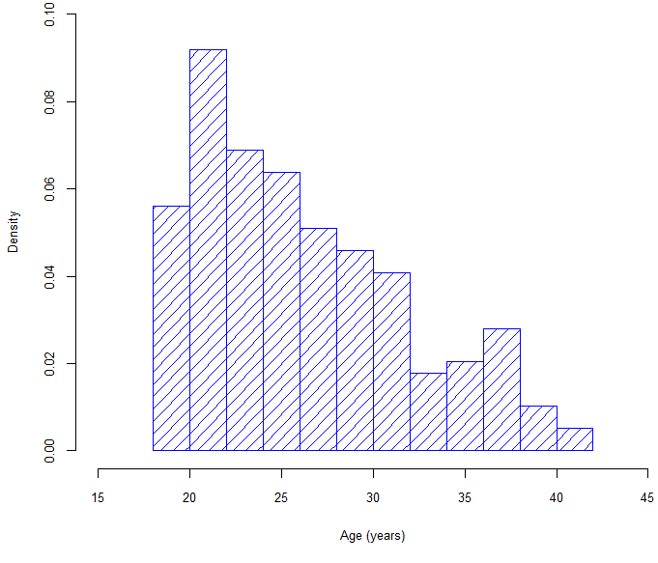

Figure 2: Distribution by marital status

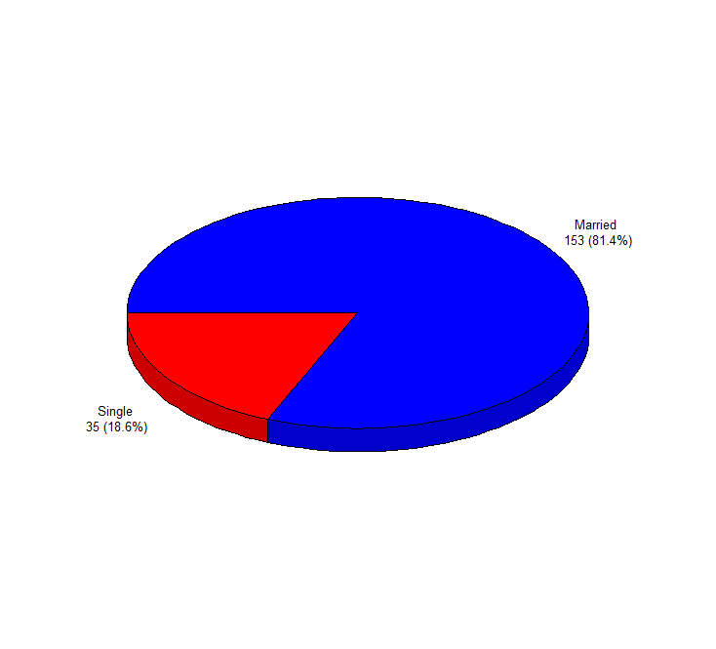
More than 80% of the participants were married.

Figure 3: Distribution of participants by occupation
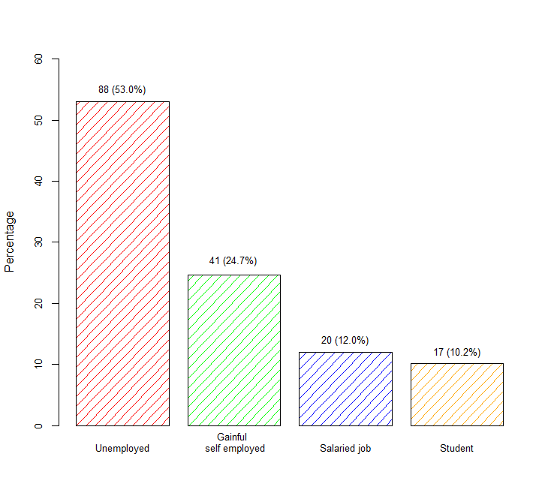

More than half were unemployed. There were 17 (10.2%) who were students. Slightly more than one third, 61 (36.7%) had gainful employment or a salaried job.

Figure 4: Distribution by the level of education

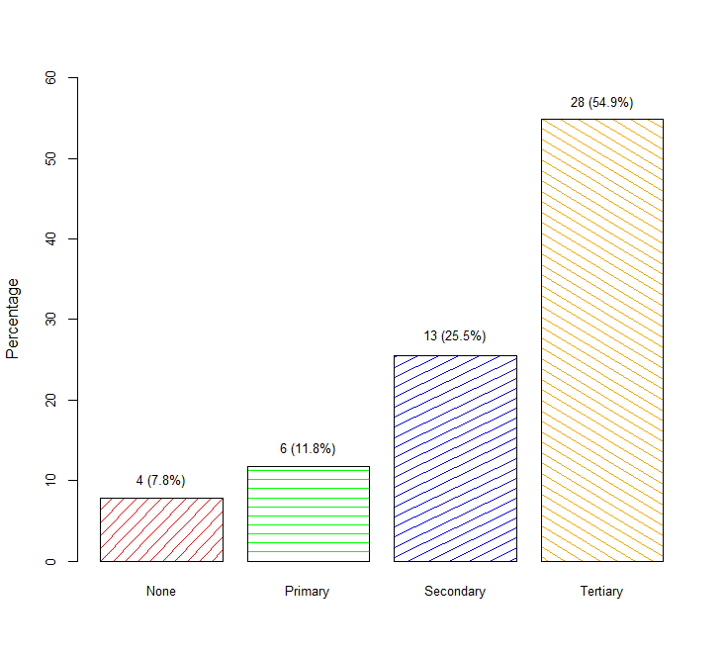
More than three quarters of the participants had at least a secondary education with majority having a tertiary education.

Figure 5: Distribution by the nature of admission
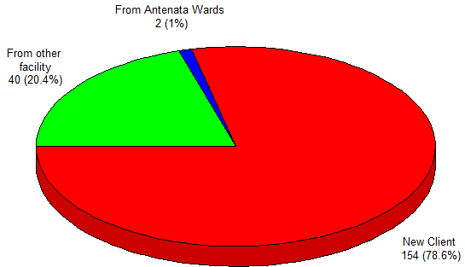
More than three quarters of the participants were new clients and one fifth were from other facilities.

Table 3: Parity, gravida and ANC profile

Variabe |  | n (%)
Gravida | One | 86 (43.9%)
 | Two | 41 (20.9%)
 | Three | 35 (17.9%)
 | Four | 17 (8.7%)
 | Five or more | 17 (8.7%)
ANC profile | Complete | 128 (65.3%)
 | Incomplete | 66 (33.7%)
 | Not done | 2 (1.0%)
The majority 86 (43.9%) were primigravida.
One hundred and ninety four attended ANC, however, 128 (65.3%) completed. Two (1.0%) did not attend ANC.

Table 4: Clinical indications for CSD

Indication | n (%)
Fetal distress | 64 (32.7%
Labor dystocia (prolonged labor, labor arrest, poor progress) | 40 (20.4%)
Malpresentation | 26 (13.3%)
Two or more previous scars in labor | 17 (8.7%)
Failed TOLAC | 11 (5.6%)
Obstructed labor | 10 (5.1%)
Delayed second stage labor | 7 (3.6%)
One PSC in labor | 5 (2.6%)
CPD | 4 (2.0%)
Severe abruption | 3 (1.5%)
Cord prolapse | 2 (1.0%)
Bleeding previa with hypovolemia | 2 (1.0%)
APH without hypovolemia | 2 (1.0%)
Failed IOL | 1 (0.5%)
Raw scar | 1 (0.5%)
Previous myomectomy in labor | 1 (0.5%)

Clinical indications show that one third of the participants, 64 (32.7%), had fetal distress, 26 (13.3%) had malpresentations, 40 (20.4%) had labor dystocia (prolonged labor, labor arrest, poor progress), and 17 (8.7%) had two or more previous scars in labor. Obstructed labor was reported for 10 (5.1%), and failed TOLAC was reported for 11 (5.6%) of the participants. Seven (3.6%) had delayed second stage. Other indications include cord prolapse, severe abruption, placenta previa with hypovolemia, APH with no hypovolemia, failed IOL, CPD, PSC in labor, raw scar, and previous myomectomy in labor.

Figure 6: Distribution by category of indication

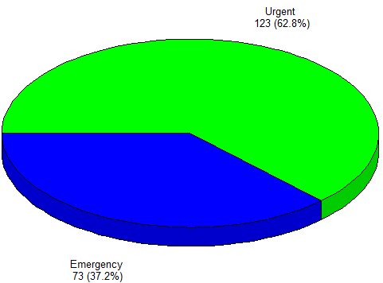

There were 73 (37.2%) caesarian cases that were category I and 123 (62.8%) that were category II.

Table 5: Surgical Personnel
Variable |  | n (%)
Lead surgeon performing the caesarean section | Consultants | 1 (0.5%)
Lead surgeon performing the caesarean section | Registrars | 190 (96.9%)
Lead surgeon performing the caesarean section | Medical Officer Intern | 5 (2.6%)

The bulk, 190 (96.9%) of the CS deliveries were performed by the reproductive health registrars.

Table 6: Practices During Cesarean Section

Practice |  |  |  |  | n (%) or Median (IQR)
Antibiotic |  |  |  |  | 196 (100%)
Thrombo-prophylaxis given |  |  |  |  | 0 0.0%)
Skin incision type |  | Pfannenstiel |  |  | 186 (94.9%)
 |  | SUMI (repeat) |  |  | 10 (5.1%)
Primary uterine incision |  | Low transverse |  |  | 195 (99.5%)
 |  | Low vertical |  |  | 1 (0.5%)

The most adopted type of skin incision was Pfannestiel which was used among 186 (94.9%) of the participants. SUMI was used in 10 (5.1%) participants.
Low transverse uterine incision was applied in 195 (99.5%) of the participants. One participant had low vertical uterine incision.

Figure 7: Distribution of Time from Decision to Delivery

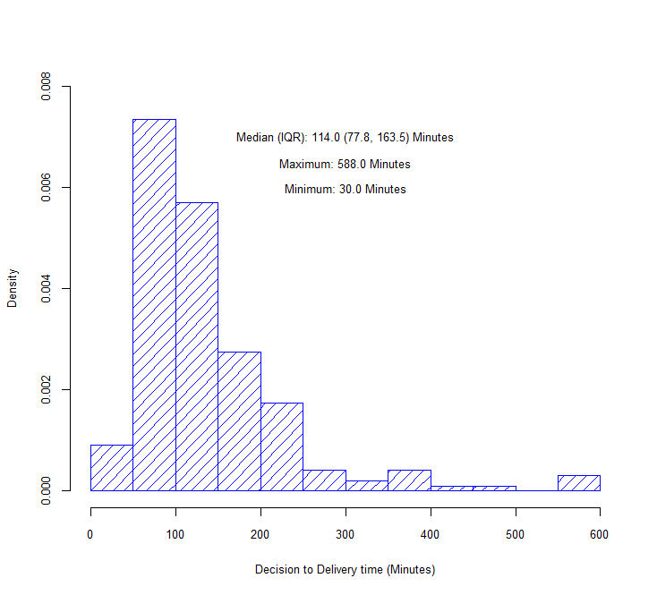

The median time from decision to delivery was 114.0 (IQR: 77.8, 163.5) minutes with a minimum and maximum of 30.0 and 588.0 minutes respectively.

Figure 8: Cumulative Percentage Deliveries over Time
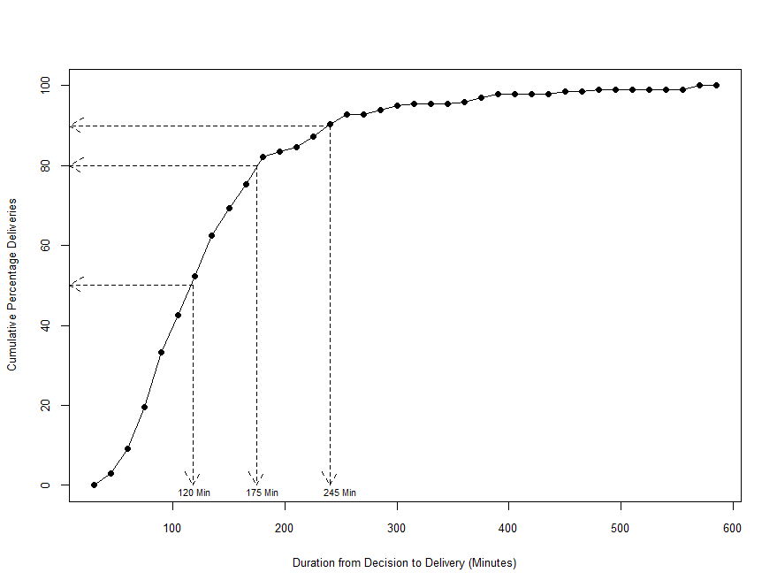

Figure 8 is an ogive showing the cumulative percentage or proportion of deliveries at each point in time. The figure shows that half the deliveries (50%) were complete by 2 hours. By 175 minutes, 80% of all the deliveries had been completed, and by 245 minutes up to 90% of all the deliveries had been completed. Ten percent of the mothers were undelivered by 245 minutes.

Table 7: Breakdown of DDI
Variable | Median (IQR)
Decision to theatre time (Minutes), Median (IQR) | 67.0 (44.3, 116.5)
Range (Min – Max) | 2.0 – 569.0
Theatre to induction time (Minutes), Median (IQR) | 30.0 (20.0, 38.0)
Range (Min – Max) | 1.0 – 170.0
Induction to skin incision time (Minutes), Median (IQR) | 2.0 (1.0, 3.0)
Range (Min – Max) | 1.0 – 24.0
Skin incision to delivery time | 4.0 (3.0, 6.0)
Range (Min – Max) | 1.0 – 19.0

Min- Minimum, Max- Maximum, IQR – Inter Quartile Range (25th Percentile, 75th Percentile)
General anesthesia was administered in 177 (90.3%) while spinal anesthesia was administered in 19 (9.7%) of the participants.

Table 8: DDI across the Different Indications
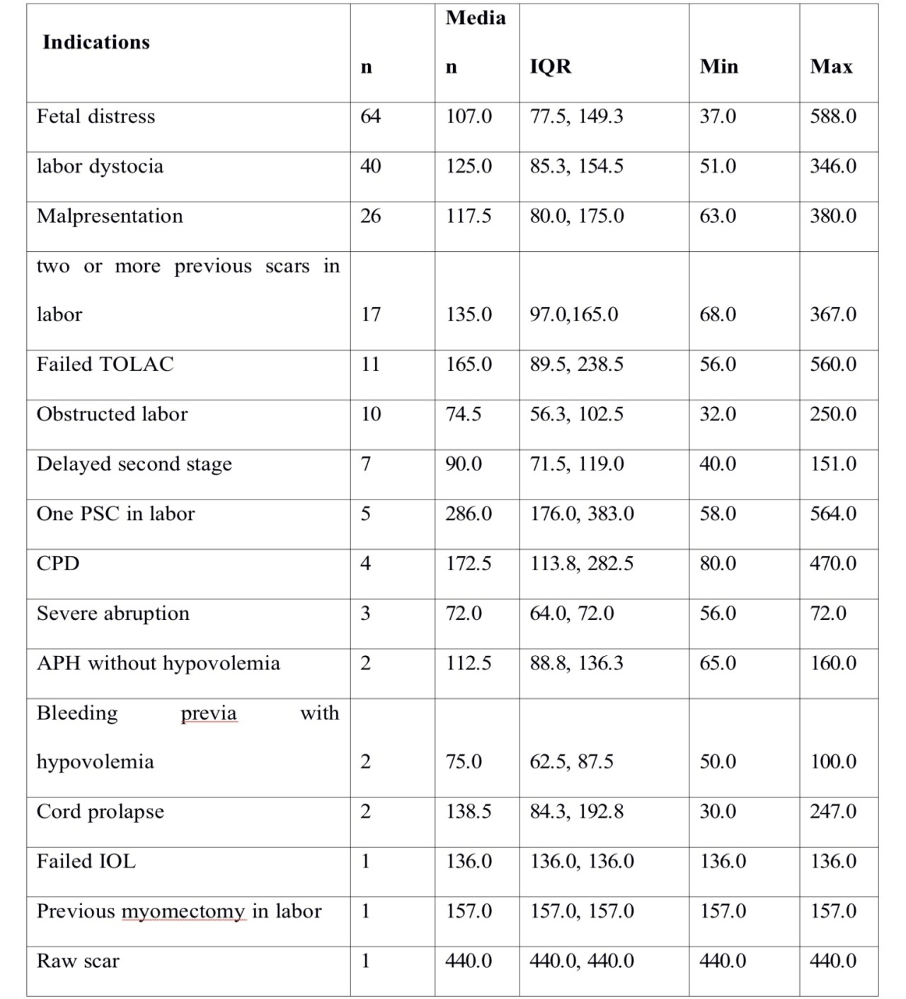
The median (IQR) APGAR scores of those who were admitted to new born unit was 7.0 (IQR: 6.0, 9.0) while the median (IQR) APGAR scores of those who were not admitted to the new born units was 10.0 (IQR: 9.0, 10.0). This difference was statistically significant, p<0.0001, implying that those who were admitted to NBU had significantly low scores compared to those who were not admitted. Restricting to those who survived, the median (IQR) APGAR score after five minutes was 10.0 (IQR: 9.0, 10.0) among those who were not admitted to the NBU and 7.0 (IQR: 6.0, 9.0) among those who were admitted to the NBU. This difference was statistically significant, p<0.0001.
Mothers with one PSC in labor had the longest median duration, 286.0 (IQR: 176.0, 383.0) minutes. Second, third fourth, and fifth in the list were the participants with CPD, failed TOLAC, two or more previous scars in labor, labor dystocia with median durations of 172.5 (IQR: 113.8, 282.5), 165.0 (IQR: 89.5, 238.5), 135.0 (IQR: 97.0, 165.0), 125.0 (IQR: 85.3, 154.5) minutes respectively. The other indications for which longer durations of at least two hours recorded included fetal distress, malpresentation, and delayed second stage.
APH without hypovolemia, cord prolapse, failed IOL, previous myomectomy in labor, and raw scar recorded the longest times. However, these constituted sample size of one or two patients only.

Table 9: Maternal Outcomes
Variable |  | n (%)
Maternal condition 24 hours after delivery | Alive and well | 175 (89.8%)
Maternal condition 24 hours after delivery | Complications | 23 (11.7%)
$Complication | PPH only | 19(82.6)
 | PPH & STAH | 3 (13.0%)
 | PE & PPH | 1 (4.3%)
Estimated blood loss at 6 hours post-delivery (ml) |  | 550.0 (425.0, 700.0)
$ - n = 23;
PPH - Postpartum Hemorrhage, PE - Pulmonary Embolism, STAH - Subtotal Hysterectomy
Within twenty four hours, 23 (11.7%) of the participants suffered complications while the rest were alive and doing well. All the participants with complications had postpartum hemorrhage. On further classification showed that of those with complications, 19 (82.6%) had postpartum hemorrhage only, 3 (13.0%) had postpartum hemorrhage necessitating sub-total hysterectomy while the remaining one had both postpartum hemorrhage, pulmonary thromboembolism. Overall 4 (2.0%) participants had extension of the uterine incision and 3 (75.0%) of these had postpartum hemorrhage alone
The median blood loss 6 hours after caesarean section was 550.0 (425.0, 700.0) ml with a minimum and a maximum of 100.0 ml and 3400.0 ml respectively. Over half of the children born were male, 110 (56.1%). The median APGAR score after five minutes was 9.0 (IQR: 8.0, 10.0) with a minimum and maximum of 0.0 and 10.0 respectively. One quarter (26%) were admitted to the new born unit. Of this number 46 (90.2%) were not in good condition and 2 (3.9%) had their mothers in bad condition. Three (5.9%) fetuses together with their mothers were not in good condition. Overall, 4 (2.0%) fetuses died shortly postpartum, and 3 (1.5%) were stillbirths.

Table 10: Fetal outcomes

Variable |  |  |  |  | Median (IQR) or n (%)
*Birth weight (grams) |  |  |  |  | 3200.0 (2900.0, 3532.5)
Child sex |  |  |  | Male | 110 (56.1%)
 |  |  |  | Female | 86 (43.9%)
APGAR score at 5 minutes |  |  |  |  | 9.0 (8.0, 10.0)
Admitted to New Born Unit |  |  |  |  | 51 (26.0%)
*  Reason for NBU admission |  |  |  | Baby’s condition | 46 (90.2%)
 |  |  |  | Mother’s condition | 2 (3.9%)
 |  |  |  | Both | 3 (5.9%)
Fetal death |  |  |  | No | 189 (96.4%)
 |  |  |  | Died Shortly postpartum | 4 (2.0%)
 |  |  |  | Fresh Stillbirth | 3 (1.5%)
* - n = 192; ** - n = 190; *** - n = 51

Table 11: Association between maternal outcomes and decision to delivery time
 |  |  |  | N | Decision to delivery time (Minutes) | Min. | Max. | P
Variable |  |  |  |  | Median (IQR)
Procedure |  |  | Urgent |  | 125.0 (83.0, 175.0) | 32.0 | 564.0 | 0.031^{w}
 |  |  | Emergency |  | 105.0 (75.0, 149.0) | 30.0 | 588.0
Maternal condition 24 hours after delivery | Alive and well |  |  | 173 | 120.0 (82.0, 165.0) | 30.0 | 588.0 | 0.054^{w}
Maternal condition 24 hours after delivery | Complications |  |  | 23 | 85.0 (73.0, 125.0) | 41.0 | 440.0

Min. – Minimum; Max. – Maximum; ^{w} – two sample - Wilcoxon rank-sum test
The results show that the participants (mothers) who underwent urgent procedure had a significantly longer duration to delivery from decision, median (IQR): 125.0 (IQR: 83.0, 175.0) minutes compared to those who underwent emergency procedure, median (IQR): 105.0 (IQR: 75.0, 149.0) minutes, p=0.013.
Mothers who had no complications (alive and well) at 24 hours after delivery took a longer duration, median (IQR): 120.0 (IQR: 82.0, 165.0) minutes compared to those who had complications, median (IQR): 85.0 (IQR: 73.0, 125.0) minutes. However, the difference was not statistically significant, p=0.054.
There was no clear evidence of any relationship between decision time to delivery with the amount of blood lost. The results however show extreme cases of blood loss among those who took time less than the median decision to delivery time. Similarly, there were extreme cases of low blood loss despite longer durations.

Table 12: Association between decision to delivery time and fetal outcomes
 |  |  |  | N | Decision to delivery time (Minutes) | Min. | Max. | P
Variable |  |  |  |  | Median (IQR)
Admitted to New Born Unit |  | No |  | 145 | 115.0 (80.0, 165.0) | 30.0 | 588.0 | 0.350^{w}
 |  | Yes |  | 51 | 110.0 (75.5, 160.0) | 32.0 | 367.0
Fetal death |  | No |  | 189 | 116.0 (79.0, 165.0) | 30.0 | 588.0
 |  | Died Shortly postpartum |  | 4 | 65.0 (57.5, 75.5) | 50.0 | 86.0 | 0.084^{k}
 |  | Fresh Stillbirth |  | 3 | 100.0 (80.0, 120.0) | 65.0 | 135.0
Min. – Minimum; Max. – Maximum; ^{w} – two sample - Wilcoxon rank-sum test; ^{k} – Kruskal – Wallis test
Admission to newborn unit was not associated with the duration taken from decision to delivery, p=0.350. Similarly, there was no sufficient evidence from the data to link longer durations to fetal death or stillbirth, p=0.084.
Majority of the children with good APGAR score were delivered within a shorter duration to delivery. However there were some infants with good scores despite longer delay.

Figure 9: Relationship between 5 minute APGAR score and DDI.
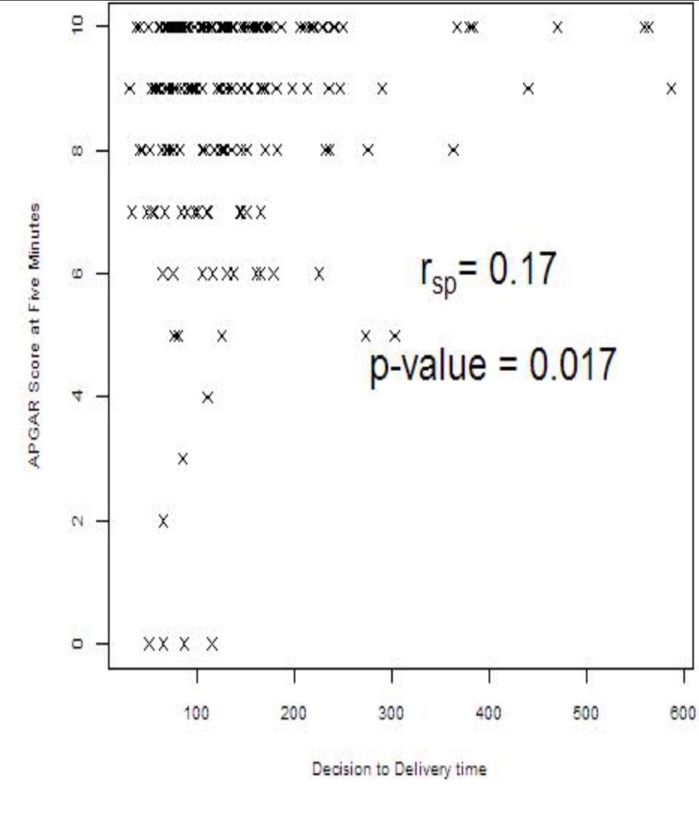
Majority of the children with good APGAR score had their mothers undergo a shorter duration to delivery. However there were some children with good scores who had their mothers undergo the procedure for longer duration.

CHAPTER FIVE

DISCUSSION
A caesarean section is a complex multidisciplinary procedure. Several steps are in the process of patient preparation as well as assemble the operating team consisting of the surgeon, scrub nurse, his/her assistant, pediatrician, anaesthetist and his/her assistant among other steps (see appendix III).
There is a generally agreed recommendation that in emergency caesarean deliveries the DDI should be within 30 minutes and this provides a large body of evidence to be quoted as suggesting negligent care should a baby be born in suboptimal condition when there has been a delay of more than 30 minutes. It may not always be possible to meet this standard in real practice.
In this study a total of 196 participants who met the inclusion criteria were included in the study for analysis. The median (IQR) age was 25.0 (IQR: 22.0, 30.0) years with a minimum and a maximum of 18.0 and 42.0 years respectively and this compares to a Nigerian study where 86.7% of emergency caesarean sections were performed among age group 25-34 years . The majority (81.4%) were married. Eighty-eight(53.0%) were unemployed, 61 (36.7%) were in gainful employment while 17 (10.2%) were students. Those with tertiary education comprised 54.9% while 19.6% didn't go beyond primary education. Only 2% attended our antenatal clinic, 20.4% referred from other facilities while 78.6 % were new clients who voluntarily chose to deliver in RMBH.
Eighty-six (43.9%) were primigravida. Among the 194 who attended ANC, 128 (65.3%) completed at least 4 visits whereas 2(1.0%) did not attend ANC at all.
The present study found the commonest indication for emergency CSD as fetal distress (32.7%) followed by labor dystocia (20.4%), malpresentation (13.3%), two or more previous scar(s) in labor (8.7%), failed TOLAC (5.6%), obstructed labor (5.1%), delayed 2nd stage (3.6%) among others. These results are consistent with Kolas et al., 2003 findings in Norway, in which the main indications for CS were fetal stress (21.9%), failure to progress (20.7%), previous cesarean delivery (8.9%).
Participants with one PSC in labor had the longest median DDI, 286.0 (IQR: 176.0, 383.0) minutes. Second, third, fourth, and fifth in the list were the participants with CPD, failed TOLAC, two or more previous scars in labor, labor dystocia with median durations of 172.5 (IQR: 113.8, 282.5), 165.0 (IQR: 89.5, 238.5), 135.0 (IQR: 97.0, 165.0), 125.0 (IQR: 85.3, 154.5) minutes respectively. The other indications for which longer durations of at least two hours recorded included fetal distress, malpresentation, and delayed second stage.
APH without hypovolemia, cord prolapse, failed IOL, previous myomectomy in labor, and raw scar recorded the longest times. However, these constituted sample size of one or two patients only.
The median time from decision to delivery was 114.0 (IQR: 77.8, 163.5) minutes with a minimum and maximum of 30.0 and 588.0 minutes respectively. Only one delivery occurred within 30 minutes of decision. About 50% of the deliveries were perfomed within 120 minutes(2 hours) while 20% remained undelivered within 175 minutes of deciding to perform EMCS. In a prospective observational study from the University of Nigeria Teaching Hospital, Nigeria, out of the 150 who were used for the study, where the mean DDI in the study population was 3.4 hours, none of the ECD in that study was performed within the recommended 30 minutes decision delivery interval (Onah HE. et al.,2005). Our study compares favorably with a study done in at Ridge Regional Hospital, Accra, Ghana; before (August–September 2011) and after (August–September 2012) introduction of an obstetric operating room. Overall, the median DDI decreased from 259 min (interquartile range [IQR] 161–432) in the pre-operating room period to 195 min (IQR 138–319) in the post-operating room qperiod (P < 0.001). Only one emergency cesarean—in the post-operating room period—was conducted within the recommended 30-minute timeframe. (Onyi Onuoha et al, 2015).
The results show that the participants (mothers) who underwent category II procedure had a significantly longer duration to delivery from decision, median (IQR): 125.0 (IQR: 83.0, 175.0) minutes compared to those who underwent category I procedure, median (IQR): 105.0 (IQR: 75.0, 149.0) minutes, p=0.013. Our study compares poorly with a European study where 68% Category 1 deliveries were achieved within 30 min and 66% Category 2 within 75 min (26% for antepartum Category 2 deliveries). (Greg et al., 2011)
The longest delay was contributed by the delay from decision making to receiving the patient in theatre, 67.0 (44.3, 116.5) minutes, followed by the period from receiving in theatre to induction of anesthesia, 30.0 (20.0, 38.0) minutes. Induction to skin incision time was 2.0 (1.0, 3.0) minutes while skin incision to delivery time was 4.0 (3.0, 6.0) minutes. If something is to be done to reduce the DDI then it would be to reduce the period between the decision to induction of anesthesia which took median time of 67 plus 30 minutes!
Majority of the children with good APGAR score had their mothers undergo a shorter duration to delivery. However there were some children with good scores who had their mothers undergo the procedure for longer duration. Possible explanations include:
- Diagnosis of severely compromised fetuses could have led to priority intervention (crash CSD) by obstetricians and inevitably poor outcome in spite of the shorter DDI.
- Agitation to expedite CSD could have increased maternal anxiety generating increased catecholamine release and reduced uterine perfusion, (MacKenzie et al.,2001).
- Intrauterine fetal resuscitation could have been successful and improved fetal status. This could be prove that intrauterine ressuscitation works.
Admission to newborn unit had no association with the duration taken from decision to delivery, p=0.350. Similarly, there was no sufficient evidence from the data to link longer durations to adverse neonatal outcome (fetal death or stillbirth, p=0.084). =0.084). Findings similar to Chauhan et al.,1997 who concluded that DDI is not associated with a measurable negative impact on newborn outcome. Failure to meet the DDI recommendations does not seem to increase neonatal morbidity (Derek, et al., 2001) Tufnell et al., did not show any significant relation between DDI and admission to a neonatal unit.
Mothers who had no complications (alive and well) at 24 hours after delivery took a longer delay to delivery, median (IQR): 120.0 (IQR: 82.0, 165.0) minutes compared to those who had complications, median (IQR): 85.0 (IQR: 73.0, 125.0) minutes. This may have originated from the provider bias in patient selection. However, the difference was not statistically significant, p=0.054.
There was no clear evidence of any relationship between decision time to delivery with the amount of blood loss. The results however show severe postpartum hemorrhage among those who took time less than the median decision to delivery time. This could have been due to prioritization of mothers with APH who are at higher risk of PPH due to possible consumption coagulopathy. Similarly, there were extreme cases of low blood loss despite longer durations. The findings are similar to those of Chauhan et al.,1997.

Limitations
- Inability to perform cord blood PH limited the objectivity in the diagnosis of presumed fetal distress as we heavily relied on clinical criteria.
- Shortage of theatre facilities in the region during the period of study worsened by gov't provision of free maternity services strained the MTRH facilities and personnel.

CHAPTER SIX

CONCLUSION AND RECOMMENDATION

6.1 Conclusion
In MTRH fetal distress is the commonest indicaton for emergency CSD followed by labor dystocia, malpresentation, previous CSD, obstructed labor then delayed 2nd stage.
The recommended DDI is not yet achievable in our setup. The longest delay was observed between decision-theatre.
The main maternal and fetal outcomes within 24 post op were PPH and birth asphyxia respectively.
Shorter DDI were associated with a higher frequency of APGAR scores above 7, and low frequency of lower APGAR scores below 7. However there were some children with good scores who had their mothers delivered after long DDI.

6.2 Recommendation:
Maternity units should consider categorising emergency CS’s to help in timing intervention and possibly factor in the EMCS protocol.
Effort should be made to reduce the time from decision to induction of anesthesia which constitutes the longest delay. Perhaps charting the times at various critical steps in a chart in the patients file would facilitate easier similar audits in the future.
A study to establish factors influencing decision to delivery intervals is highly recommended and this may also reveal other factors that would influence fetomaternal outcomes in a complex manner.

Acknowledgement

- MTRH Management
- IREC
- Department of Reproductive Health
- My supervisors- Dr. P. Tonui and Dr. M. Pallavi
- Research assistants- Dr. Gideon Ngetich
- Dr. Cosmas Sang'
- Fellow Registrars.

REFERENCES
ACOG Committee on Obstetric Practice. (2006). ACOG Committee Opinion No. 340. Mode of term singleton breech delivery. Obstetrics and gynecology, 108(1), 235.
Adamsons, K., & Myers, R. E. (1977). Late decelerations and brain tolerance of the fetal monkey to intrapartum asphyxia. American journal of obstetrics and gynecology, 128(8), 893-900.
Annappa, R., Campbell, D. J., & Simpson, N. A. (2008). Fetal blood sampling in labour and the decision to delivery interval. European Journal of Obstetrics & Gynecology and Reproductive Biology, 141(1), 10-12.
Berg, D. and Ratzel, R. (1995) Minimum requirements for procedural, structural and organizational precondi- tions for obstetric departments. Frauenarzt, 36, 27-33.
Boley JP. The History of Caesarean Section. Can Med Assoc J.1991;145:319–22.
Brian VA. The deepest cut of all. Nursing Mirror 1976; 143:68-69.
Cecatti JG. Antibiotic prophylaxis for caesarean section: RHL commentary (last revised: 18 January 2005). The WHO Reproductive Health Library; Geneva: World Health Organization.
Cerbinskaite, A., Malone, S., McDermott, J., & Loughney, A. D. (2011). Emergency caesarean section: influences on the decision-to-delivery interval. Journal of pregnancy, 2011.
Chauhan SP, Roach H, Naef RW, et al. Caesarean section for suspected fetal distress: does the decision to interval time make a difference?. J Reprod Med 1997;42: 347–352.
Cheong YC, Premkumar G, Metwally M, Peacock JL, Li TC. To close or not to close? A systematic review and a meta-analysis of peritoneal non-closure and adhesion formation after caesarean section. Eur J Obstet Gynecol Reprod Biol. 2009;147(1):3–8.
Cochran WG. Sampling Techniques. 2nd ed. New York: John Wiley and Sons, Inc., 1963.
Collea JV, Chein C, Quilligan EJ. The randomized management of term frank breech presentation: a study of 208 cases. Am J Obstet Gynecol 1980;137(2):235–44.
Collea JV, Chein C, Quilligan EJ. The randomized management of term frank breech presentation: a study of 208 cases. Am J Obstet Gynecol 1980;137(2):235–44.
Confidential enquiry into stillbirths and deaths in infancy. Focus Group. Anaesthetic anaesthesia delays and complications. 7th Annual Report, London: Maternal and Child Health Research Consortium; 2000, pp. 41–52
Cunningham FG, Hauth JC, Wenstrom KD, Leveno KJ, Gilstrap L, Bloom SL, eds. Williams Obstetrics. 22nd ed. New York: McGraw-Hill;2005.
Derek J Tuffnell, consultant (derek.tuffnell@bradfordhospitals.nhs.uk), Kath Wilkinson, clinical governance support officer, Nicola Beresford, senior house officer: Interval between decision and delivery by caesarean section—are current standards achievable? Observational case series. BMJ 2001
Diabetes in pregnancy: Management of diabetes and its complications from pre-conception to the postnatal period; NICE Clinical Guideline ( 2008)
DJ Lyell and AB Caughey. External Cephalic Version: A Terrible Opportunity To Waste. Journal of Perinatology, 2009.
Draycott, T. J., Crofts, J. F., Ash, J. P., Wilson, L. V., Yard, E., Sibanda, T., & Whitelaw, A. (2008). Improving neonatal outcome through practical shoulder dystocia training. Obstetrics & Gynecology, 112(1), 14-20.
Dunphy BC, Robinson JN, Sheil OM, Nicholls JSD, Gillmer MDG. Caesarean section for fetal distress, the interval from decision to delivery, and the relative risk of poor neonatal condition. J Obstet Gynaecol. 1991;11:241–244.
Dwyer JP. Proceedings of Fourth International Scientific Meeting of the RCOG. London: Royal College of Obstetricians and Gynaecologists; 1999. Decision to delivery time in emergency caesarean section.
East CE, Leader LR, Sheehan P, et al. Intrapartum fetal scalp lactate sampling for fetal assessment in the presence of a non-reassuring fetal heart rate trace. The Cochrane Database of Systematic reviews. 2010(3).
Elvedi-Gasparovic V, Klepac-Pulanic T, Peter B. Maternal and fetal outcome in elective versus emergency cesarean section in a developing country. Coll Antropol. 2006;30:113-118.
Erin A.S. Clark MD,Robert M. Silver MD, Long-term maternal morbidity associated with repeat cesarean delivery
Gabert HA, & Bey M. History and development of Cesarean Operation. Obstetrics and Gynecology clinics in North America 1988; 15:591-605.
Gaffney G, Sellers S, Flavell V, Squier M, Johnson A. A case-control study of intrapartum care, cerebral palsy, and perinatal death. BMJ. 1994;308:743–750. [PMC free article] [PubMed]
Geidam; B Bako,S Ieschin, Maslin: Early neonatal outcome of babies delivered by cesarean section because of clinical diagnosis of fetal distress, 2009
Gimovsky ML, Wallace RL, Schifrin BS, Paul RH. Randomized management of the nonfrank breech presentation at term: a preliminary report. Am J Obstet Gynecol 1983;146(1):34–40.
Gimovsky ML, Wallace RL, Schifrin BS, Paul RH. Randomized management of the nonfrank breech presentation at term: a preliminary report. Am J Obstet Gynecol 1983;146(1):34–40.
Greg A. Pearson, Brenda Kelly, Robin Russell, Susan Dutton, Jenny J. Kurinczuk, Ian Z. MacKenzieTarget decision to delivery intervals for emergency caesarean section based on neonatal outcomes and three year follow-up (2011): 159; 276-281
Gulzar Shah, MStat, MSS, PhD, Pamela A. Clarkson Freeman, PhD, Keely Cofrin, PhD,Wu Xu, PhD. Cesarean Deliveries and Newborn Injuries: Evidence from Linked Utah Birth Certificate and Inpatient Discharge Data
Gupta, M. (2008). The birth of caesarean section. University Of Western Ontario Medical Journal, 78(1), 79-85.
Gwer S O. The application of good operative practices and optimality of the diagnosis of common indications for emergency cesarean delivery at Kenyatta National Hospital – Nairobi Kenya. 2006.
Hannah ME, Hannah WJ, Hewson SA, Hodnett ED, Saigal S, Willan AR. Planned Caesarean section versus planned vaginal birth for breech presentation at term: a randomised multicentre trial. Term Breech Trial Collaborative Group. Lancet 2000;356(9239):1375–83.
Hannah WJ, Baskett TJ, Chance GW, et al. Indications for caesarean section: final statement of the panel of the National Consensus Conference on Aspects of Cesarean Birth. Canadian Medical Association Journal 1986;134: 1348–52.
Harris RP. Remarks on the Cesarean Operation. American Journal of Obstetrics and Gynecology 1879; 11:620-626.
Hillan EM. Caesarean Section: historical background. Scottish Medical Journal 1991; 36(5):150-154.
Hillan EM. Caesarean section: historical background. Scot Med J. 1991;36:150-4.
Hillemanns P, Hasbargen U, Strauss A, Schulze A, Genzel-Boroviczeny O, Hepp H. Maternal and neonatal morbidity of emergency cesarean sections with a decision to delivery interval under 30 minutes. Arch Gynecol Obstet. 2003;268:136-141.
Hofmeyr GJ, Hannah ME. Planned Caesarean section for term breech delivery. Cochrane Database Syst Rev 2008;(3)
Fadel, H. E. (2011). Postmortem and perimortem cesarean section: historical, religious and ethical considerations. The Journal of IMA, 43(3), 194.
J. Thomas, S. Paronjothy, National Sentinel Cesarean Section Audit Report. RCOG Clinical Effectiveness Support Unit. RCOG Press; 2001.
James D. Caesarean section for fetal distress : The 30 minute yardstick is in danger of becoming a rod for our backs. British Medical Journal, 2001;322(7298), 1316–1317.
Jane Eliot Sewell. caeserean section-- a brief history. The American College of Obstetricians and Gynecologists in cooperation with the National Library of Medicine
Julie S. Moldenhauer, MD, Fetal Dystocia, 2016
Karen Born,Jill Konkin, Joshua Tepper & Nan Okun. Pulling back the curtain on Canada's rising C-section rate. May 29, 2014
Lavender T, Hart A, Smyth RMD. Effect of partogram use on outcomes for women in spontaneous labour at term (Review). The Cochrane Library, 2009
Leung TY, Stuart O, Suen SS, et al; Comparison of perinatal outcomes of shoulder dystocia alleviated by different type and sequence of manoeuvres: a retrospective review. British Journal of Obstetrics and Gynecology. 2011 Jul;118(8):985-90.
Lim, Y., Shah, M. K., & Tan, H. M. (2005). Evaluation of surgical and anaesthesia response times for crash caesarean sections-an audit of a Singapore hospital. ANNALS-ACADEMY OF MEDICINE SINGAPORE, 34(10), 606.
Low J. Caesarean section–past and present. J Obstet Gynaecol Can. 2009;31:1131–6.
Lucas DN. The 30-minute decision to delivery time is unrealistic in morbidly obese women. Int J Obstet Anesth. 2010;19(4):431–435. Comment by: Dresner M. Int J Obstet Anesth. 2010;19(4):435–437.
Mackenzie I Z et al: Indications of CS in a Consultant Obstetric Unit over Three Decades, Journal of Obstetric & Gynae 2007, 23:3, 233 –238.
MacKenzie, clinical reader in obstetrics and gynaecology and Inez Cooke, clinical lecturer in obstetrics and gynecology. British Medical Journal . Jun 2, 2001; 322(7298): 1334–1335.
Mark Rollins and Jennifer Lucero:Overview of anesthetic considerations for Cesarean delivery
Mazouni C, Menard JP, Porcu G, et al; Maternal morbidity associated with obstetrical maneuvers in shoulder dystocia. Eur J Obstet Gynecol Reprod Biol. 2006
Murphy D, Sellers S, MacKenzie IZ, Yudkin PL, Johnson A. A case-control study of antenatal and intrapartum risk factors for cerebral palsy in very preterm singleton babies. Lancet. 1995;346:1449–1454. [PubMed]
Onah H E et al: Decision to Delivery Interval and Perinatal Outcomes in Emergency Cesarean Section: Journal of Obstet. & Gynae; 2005: 25(4): 342 –346
Osama Naji, Yazan Abdalah, Sara Paterson-Brown. Cesarean Birth: Surgical Techniques, 2010.
Pearce, J. M. S. (2005). Virginia Apgar (1909–1974): Neurological evaluation of the newborn infant. European neurology, 54(3), 132-134.
Philippe H Girerd, MD; Chief Editor: Ronald M Ramus, MD Breech Delivery, 2015.
Pondaag, W., R. H. Allen, and M. J. A. Malessy. "Correlating birthweight with neurological severity of obstetric brachial plexus lesions.": An International Journal of Obstetrics & Gynaecology 118, no. 9 (2011): 1098-1103.
Radhakrishnan G, Yadav G, Vaid N B, & Ali H. Factors affecting “decision to delivery interval” in emergency caesarean sections in a tertiary care hospital: a cross sectional observational study. International Journal of Reproduction, Contraception, Obstetrics and Gynecology, 2013;2 (4), 651-656.
Rizzo, M. L. (2007). Statistical computing with R. CRC Press.
Robert L. Barbieri, MD Crash cesarean section: What is your decision-to-delivery time? Effective response times require coordination of a multidisciplinary team. July 2006; 18 (7)
Royal College of Obstetricians and Gynecologists Clinical Effectiveness Support Unit. The National Sentinel Caesarean Section Audit Report. London: RCOG Press; 2001, http://www.rcog.org.uk/orca/audit/completed-audits.
Sekhavat L, Firouzabadi RD, Mojiri P. Effect of expansion technique of uterine incision on maternal blood loss in cesarean section. Arch Gynecol Obstet. 2010;282(5):475–479.
Shi Z, Ma L, Yang Y, Wang H, et al. Adhesion formation after previous caesarean section - a meta-analysis and systematic review. BJOG. 2011;118(4):410–422. doi: 10.1111/j.1471-0528.2010.02808.x.
Shoulder dystocia, Royal College of Obstetricians and Gynaecologists (2012)
Storyl, Paterson-Brown. Cesarean Deliveries: Indications, Techniques and Complications. Published by Cambridge University Press, 2009.
Thaker SB, Stroup DF. Continuous electronic heart rate monitoring for fetal assessment during labour. Cochrane Database of Systematic Reviews 2001;(1):CD000063. [PubMed]
Tita, A. T., Rouse, D. J., Blackwell, S., Saade, G. R., Spong, C. Y., & Andrews, W. W. (2009). Evolving concepts in antibiotic prophylaxis for cesarean delivery: A systematic review. Obstetrics and gynecology, 113(3), 675.
Todman D. A history of Caesarean section: from ancient world to the modern era. Aust. N Z J Obstet Gynaecol. 2007;47:357–61.http://doi.org/bn3zcc.
Tufnell DJ, Wilkinson K, Beresford N. Interval between decision and delivery by caesarean section—are current standards achievable? Observational case series. BMJ. 2001;322:1330–1333.

Van den Berg PP, Nelen WL, Jongsma HW, Nijland R, Kollee L A, Nijhuis JG, et al. Neonatal complications in newborns with an umbilical artery pH <7.00. Am J Obstet Gynecol. 1996;172:805–810.
Visnja Korda, Roland Zimmermann. Five-year impact of a new departmental protocol on emergency cesarean target times. Open Journal of Obstetrics and Gynecology, 2013, 3, 148-153
Warraich Q, Esen U. Perimortem caesarean section. J Obstet Gynaecol. 2009;29:690–3.http://dx.doi.org/10.3109/01443610903165511.
Whitworth MK,Bricker L How to perform intrapartum fetal blood sampling. British Journal of Hospital Medicine. 2006;67(9):M162-4.
Wiberg-Itzel E, Lipponer C, Norman M, et al. Determination of pH or lactate in fetal scalp blood in management of intrapartum fetal distress: randomised controlled multicentre trial. BMJ. 2008;336(7656):1284-7.
Witt, A., Döner, M., Petricevic, L., Berger, A., Germann, P., Heinze, G., & Tempfer, C. (2011). Antibiotic prophylaxis before surgery vs after cord clamping in elective cesarean delivery: a double-blind, prospective, randomized, placebo-controlled trial. Archives of Surgery, 146(12), 1404-1409.
Wu, W. L. (2000). Cesarean delivery in Shantou, China: a retrospective analysis of 1922 women. Birth, 27(2), 86-90.
Young JH. Caesarean Section: The History and Development of the Operation From Earliest Times. London, HK Lewis & Co Ltd, 1944. 13

APPENDICES

Appendix I: Consent Form
My name is ................................(research assistant name). Dr Lewenei is a medical doctor currently pursuing Masters Degree in Reproductive Health and as a requirement of his course, he is doing a dissertation on delivery time for emergency deliveries. He would like to find out how the decision for you to undergo a cesarean delivery was made, and the time it takes to perform the operation. He would also like to find out some of the details about the procedure as it was done on you as well as health details about you and your newborn baby. All this information is available in your file and you need not answer any questions. Your participation in the study will in no way change the treatment plan that your doctors deem fit for you and/or your baby, or in any other way prejudice either of you.
This study will not put you or your baby at any risk and no extra benefit may accrue to you but the findings of this study may be used to improve maternity care in the future and may be published in medical journals and/or presented in scientific symposia.
Information gathered will be treated with utmost confidentiality; your identity will be
protected (your name will not be used and you will be identified with a number, only
known to me and my immediate assistant).
The Institutional Research and Ethics Committee (IREC) of Moi University has approved this research. For any questions or clarification, please contact
Dr. Michael Lewenei Byegon
Mobile phone no. 0720738777 email address michaellewenei@yahoo.com
Moi University, Eldoret, Kenya.
I __________________________________________________ hereby accept to
participate in this study having been explained to and understood the purpose and
procedures involved. I have not been given any inducement to participate in this study.
Signature _____________________________Date---------------------------------
Witness ______________________________Date_______________________

Fomu ya kibali
Jina langu ni ..................(Mtafiti msaididizi). Lewenei ni daktari katika Wizara ya Afya. Kwa sasa amesomea shahada ya uzamili katika fani ya utabibu inayojihusisha na uzazi na maswala ya afya ya wanawake. Kimojawapo cha matarajio ya kozi hii ni kuandika tasnifu. Nimechagua kusomea vipengele fulani vya uzazi kwa njia ya mkasi. Ningependa kufahamishwa jinsi ambavyo uamuzi wako wa kujifungua kupitia uzazi wa
mkasi ulivyoafikiwa, na muda kutoka wakati uamuzi huo unapoafikiwa hadi mtoto kuzaliwa. Pia, ningependa kufahamu kwa undani baadhi ya mambo kuhusu njia hii ya kujifungua jinsi ulivyofanyiwa wewe. Zaidi ya hayo, nitakuwa nikichukua habari zako za afya pamoja na za mwanao mchanga. Habari hizi zote zimo ndani ya jalada lako wala huhitajiki kujibu maswali yo yote. Hautapata madhara yoyote kwa kubali kuhusishwa. Kushiriki kwako katika uchunguzi huu hakutabadilisha mpango wa matibabu
uliopendekezwa na madaktari wako kwamba unakufaa wewe pamoja na mwanao. Habari utakazonipa zitahifadhiwa kwa siri na kamwe hutatambuliwa. (Jina lako halitatumiwa) Habari zitakazopatikana zitatumiwa kuboresha huduma hospitalini na zinaweza kuchapishwa katika majarida ya kimatibabu. Pia zitaweza kutumiwa katika kongamano za kisayansi.
Kamati ya Maadili na Utafiti ya Chuo Kikuu cha Moi, tayari imeidhinisha uchunguzi huu. Maswali yo yote yanaweza kuelekezwa kwangu Dr. Michael Lewenei Byegon
Mobile phone no. 0720738777 email address michaellewenei@yahoo.com
Moi University, Eldoret, Kenya.
Kibali
Mimi…………………………………………………………………………, nakubali
kushiriki katika uchunguzi huu baada ya kuelezwa na kufahamu dhamira yake pamoja
mbinu husika. Sijashawishiwa kwa vyo vyote vile ili nishiriki.
Sahihi……………………………………………………………………………..
Shahidi…………………………………………………………………………….
Tarehe…………………………………………………………………………….

Appendix II: Data Collection Form
To be administered to all eligible women on whom a decision to be delivered by emergency cesarean has been made. ( Tick next to the appropriate response)
Date_______________
Patient study serial no.______________
In patient no.__________________
A. Socio-demographic factors
1. Age completed in years________
2. Marital status
• Single
• Married
• Widowed
• Divorced /separated
3. Occupation
• Unemployed
• Gainful self employment
• Salaried employment
• Student
• Other ___________________
4. Level of completed education
• Primary
• Secondary
• Tertiary
• None
B. Obstetric parameters and practices
1. Admission status
• New client
• Referred from the antenatal wards
• Referred from other health facility
2. Parity at diagnosis, Para__________Gravida____________
3. Antenatal profile available at the time of decision for cesarean section
- Complete (blood group, Hb, VDRL, HIV)
- Incomplete (missing the results of any one or more of the above mentioned in the parentheses under “complete”)
- Not done
4. Indication for this cesarean delivery
Category I (Emergency): Immediate threat to life of woman or fetus
            - Acute fetal distress/Fetal bradycardia
            - Cord prolapse
            - Severe placenta abruptio
            - Bleeding placenta previa major with maternal hypovolemia
            - Vasa previa
            - Uterine rupture and scar dehiscence
            - Failed instrumental delivery with fetal distress
Category II (Urgent): Maternal or fetal compromise but not immediately life threatening
            - Malpresentation in labor e.g. Brow presentation, face mentum posterior, transverse lie
            - Antepartum hemorrhage without hypovolemia
            - Failed IOL
5. Senior-most consultation making the decision?
- Registrar
- Consultant Obstetrician
- Medical officer intern
6. Surgeon performing the cesarean section
- Registrar
- Consultant obstetrician
- Medical officer intern
7. Decision to Delivery Interval ________ minutes
- Time of decision for emergency cesarean section _____________________
- Time patient is received in theatre____________________
- Time of induction of spinal anesthesia_______________________
- Time of induction of general anesthesia_________________________
- Time of incision of skin__________________________________
- Time of delivery of infant____________________________________
- Total time from Decision to Delivery in minutes___________________
8. Prophylactic Antibiotics given. Drug_____________Dose____________ Not Given______
9. Thrombo-prophylaxis given. Drug_____________Dose____________ Not Given______
10. Skin Incision Type
• Joel-Cohen
• Pfannenstiel
• Sub umbilical midline
• Other (specify)_____________
11. Primary Uterine incision
- Low transverse
- Low vertical
- Classical
C. Type of Anesthesia
• Epidural
• Spinal
• General anaesthesia
D. Maternal outcomes
1. Maternal condition 24hrs after delivery
• Alive and well
• Alive but with complication. (Specify) __________________
• Dead
2. Estimated blood loss 6 hours post cesarean section _________mls
3. Visceral injury, intra operative.
• None
• Extension of uterine incision
• Urinary bladder injury
• Sub Total Hysterectomy
- Need for intensive care
- Uterine rupture
- Uterine dehiscence
- VVF/RVF
- Thromboembolism
- Febrile illness
- Others (specify) ____________
E. Fetal outcomes
1. Birth weight ___________grams
2. Sex __________
3. APGAR score at 5 min _________
4. Admission to New Born Unit (NBU). Yes___________ No______________
If yes reason for admission
• Due to baby's condition
• Due to maternal condition
If baby dead,
            - Fresh still birth
            - Macerated still birth

Appendix III: What has to be done between decision to deliver and delivery

Informed consent:

Consent form signed

Intravenous access

Blood samples to be taken

Blood forms to be filled in

Bloods to laboratory

Intravenous fluids running

Premedication to be got from drug cupboard

Premedication drawn up

Premedication injected

Anaesthetist informed

Operating department assistant informed

Consultant to be informed

Anaesthetist to arrive

Operating department assistant to arrive

Theatre to be set

Scrub nurse to scrub

Packs to be opened

Sutures to be opened

Monitoring to be discontinued

Intravenous lines to be secured

Fetal scalp clip to be removed

Woman to be moved to theatre:

Woman to be moved on to theatre table

Spinal pack to be opened

Anaesthetist to scrub

Spinal drugs to be drawn up

Monitoring to be attached

Spinal anaesthesia

Wait for block to work:

Paediatrician to be present

Resuscitaire to be checked

Catheter

Shave

Surgeons to scrub

Skin preparation

Skin incision

Sheath incision

Peritoneum opened

Bladder reflected

Uterine incision

Deliver baby

Appendix IV: RCOG Good Practice Guideline
Category I(Emergency): Immediate threat to life of woman or fetus
            - Acute fetal distress/Fetal bradycardia
            - Cord prolapse
            - Severe placenta abruptio
            - Bleeding placenta previa major with maternal hypovolemia
            - Vasa previa
            - Uterine rupture and scar dehiscence
            - Failed instrumental delivery with fetal distress
Category II(Urgent): Maternal or fetal compromise but not immediately life threatening
            - Malpresentation in labor e.g. Brow presentation, face mentum posterior
            - Antepartum hemorrhage without hypovolemia
            - Failed IOL
Category III(Scheduled): Needing early delivery but no maternal or fetal compromise
            - Early labor in woman booked for elective LUSCS
            - Macrosomic baby in early labor
            - Breech in early labor
Category IV(Elective): At a time to suit the woman and maternity team
            - Previous LUSCS X 2
            - Refused TOS
            - Breech presentation
            - Multiple pregnancy
            - HIV and HSV
            - Maternal request

Appendix V: Timelines
 | March 14 | May 14 | June-14 | July-14 | Sept-14 | Oct-14 | Nov-14 | Nov/Dec-14 | Jan-15 | Aug- 15 | Dec-15
Developing proposal(Introduction,Literature review & Methodology)
Presenting proposal to supervisors
Developing data collection tools
Proposal Submission to IREC
Piloting data collection tools
Finalisation of data collection tools
Data collection
Data entry, coding and cleaning
Interim analysis
Final Analysis
Thesis write up(results, discussion)
Notice of intent to submit
Mock defence
Submission of Thesis for Examination
Thesis defence
Graduation

Appendix VI: Budget
Items | Quantity | Unit Price (Kshs) | Total (Kshs)
Stationery & Equipment
Printing Papers | 5 reams | Error! No bookmark name given.500.00 | 2,500.00
Black Cartridges | 2 | 2,000.00 | 4,000.00
Writing Pens | 1 packet | 500.00 | 500.00
Flash Discs | 1 | 2,000.00 | 2,000.00
Box Files | 2 | 200.00 | 400.00
Document Wallets | 2 | 50.00 | 100.00
Sub total |  |  | 9,500.00
Research Proposal Development
Printing drafts & final proposal | 10 copies | 500.00 | 5,000.00
Photocopies of final proposal | 6 copies | 100.00 | 600.00
Binding of copies of Proposal | 5 copies | 100.00 | 500.00
Sub total |  |  | 6,100.00
Personnel
Biostatistician | 1 | 10,000.00 | 10,000.00
Sub total |  |  | 10,000.00
Thesis Development
Printing of drafts and final thesis | 10 copies | 800.00 | 8,000.00
Photocopy of final thesis | 6 copies | 200.00 | 1,200.00
Binding of thesis | 6 copies | 300.00 | 1,800.00
Sub total |  |  | 11,000.00
Total |  |  | 36,600.00
Miscellaneous Expenditure (10% of Total) |  |  | 3,660.00
Grand Total |  |  | 40,260.00

Appendix VII: MTRH Approval

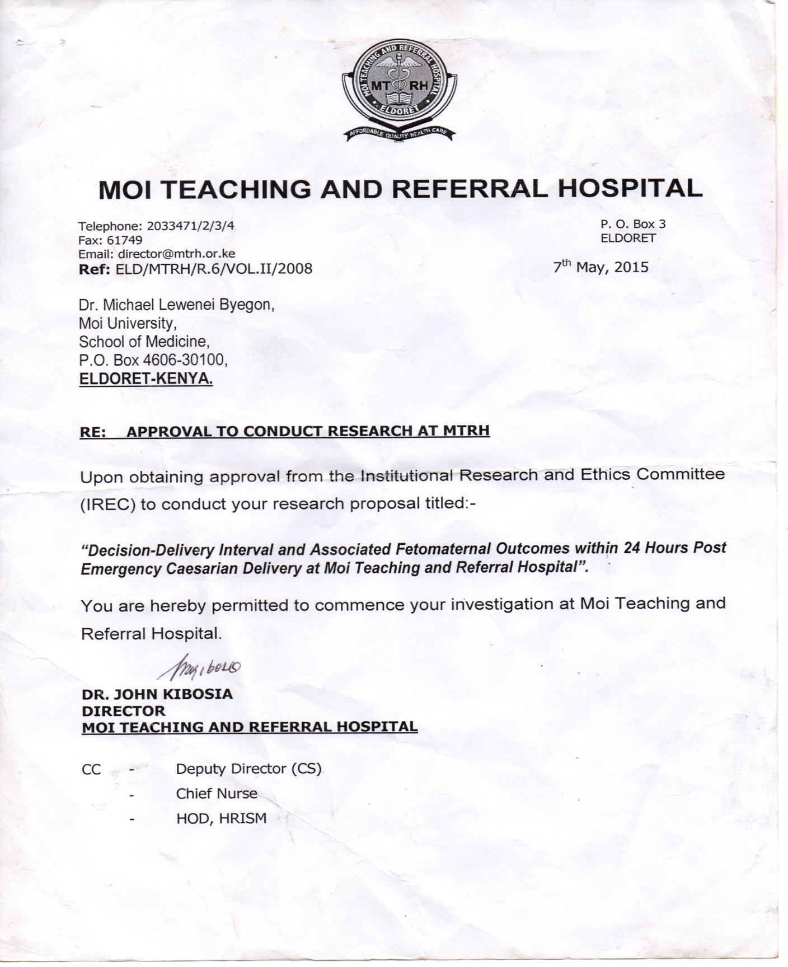
Appendix VIII: IREC Approval

