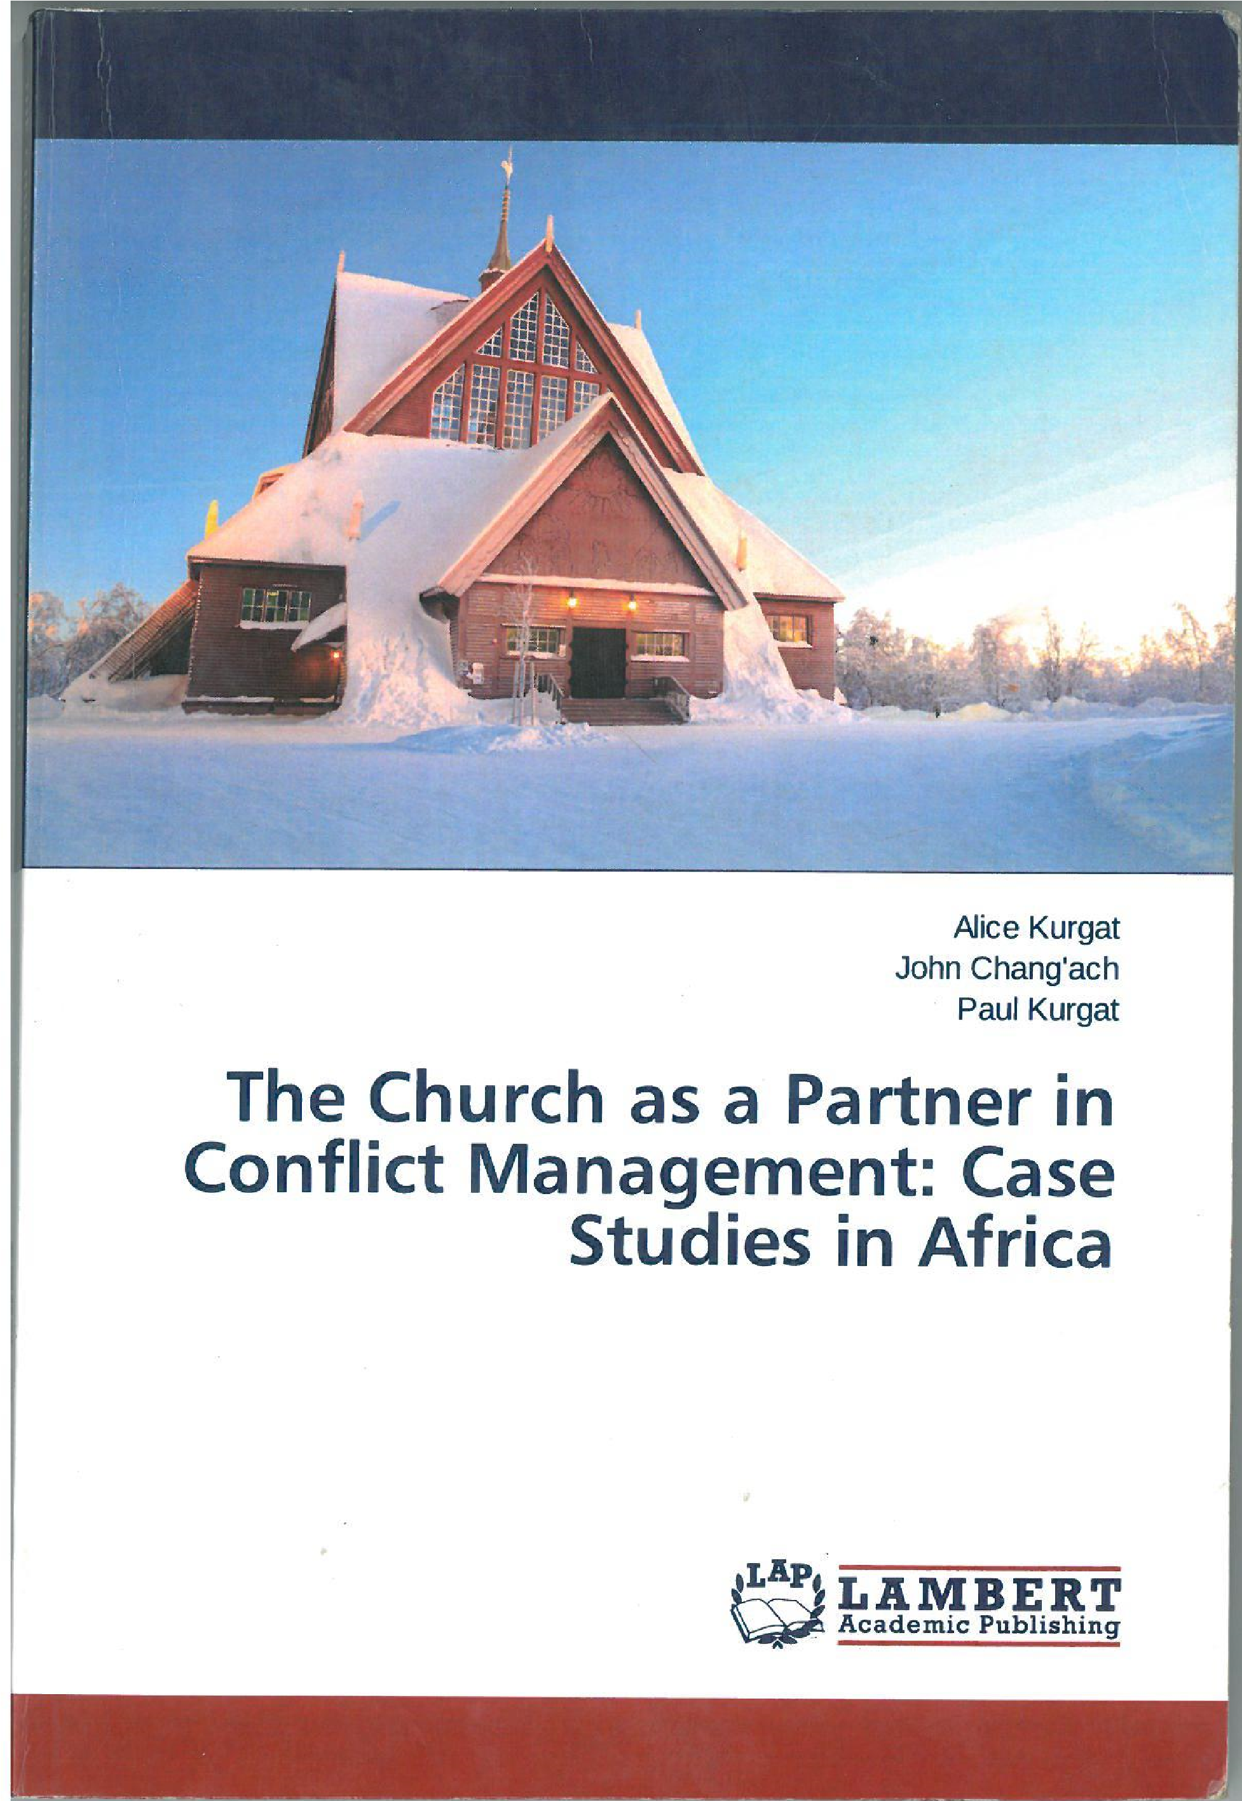
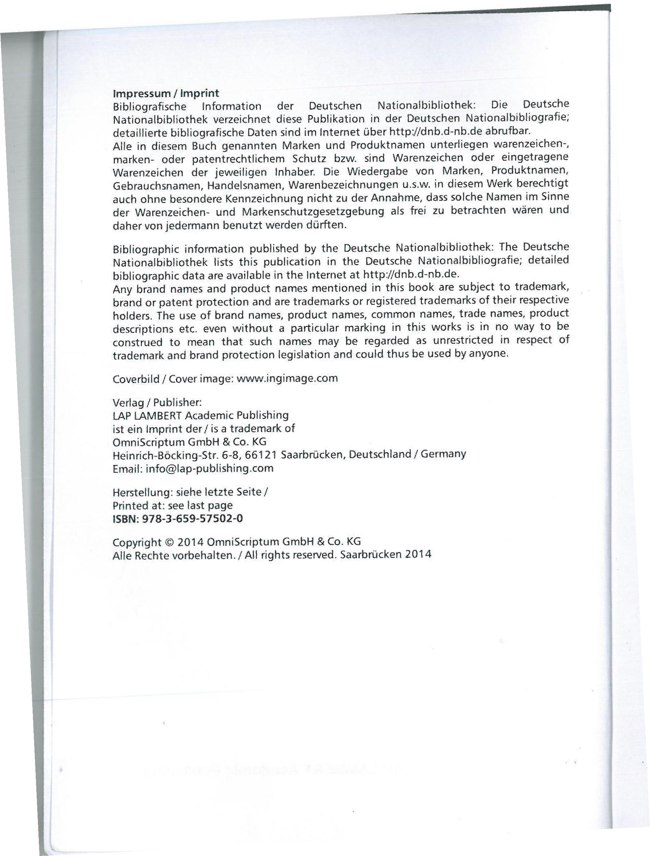
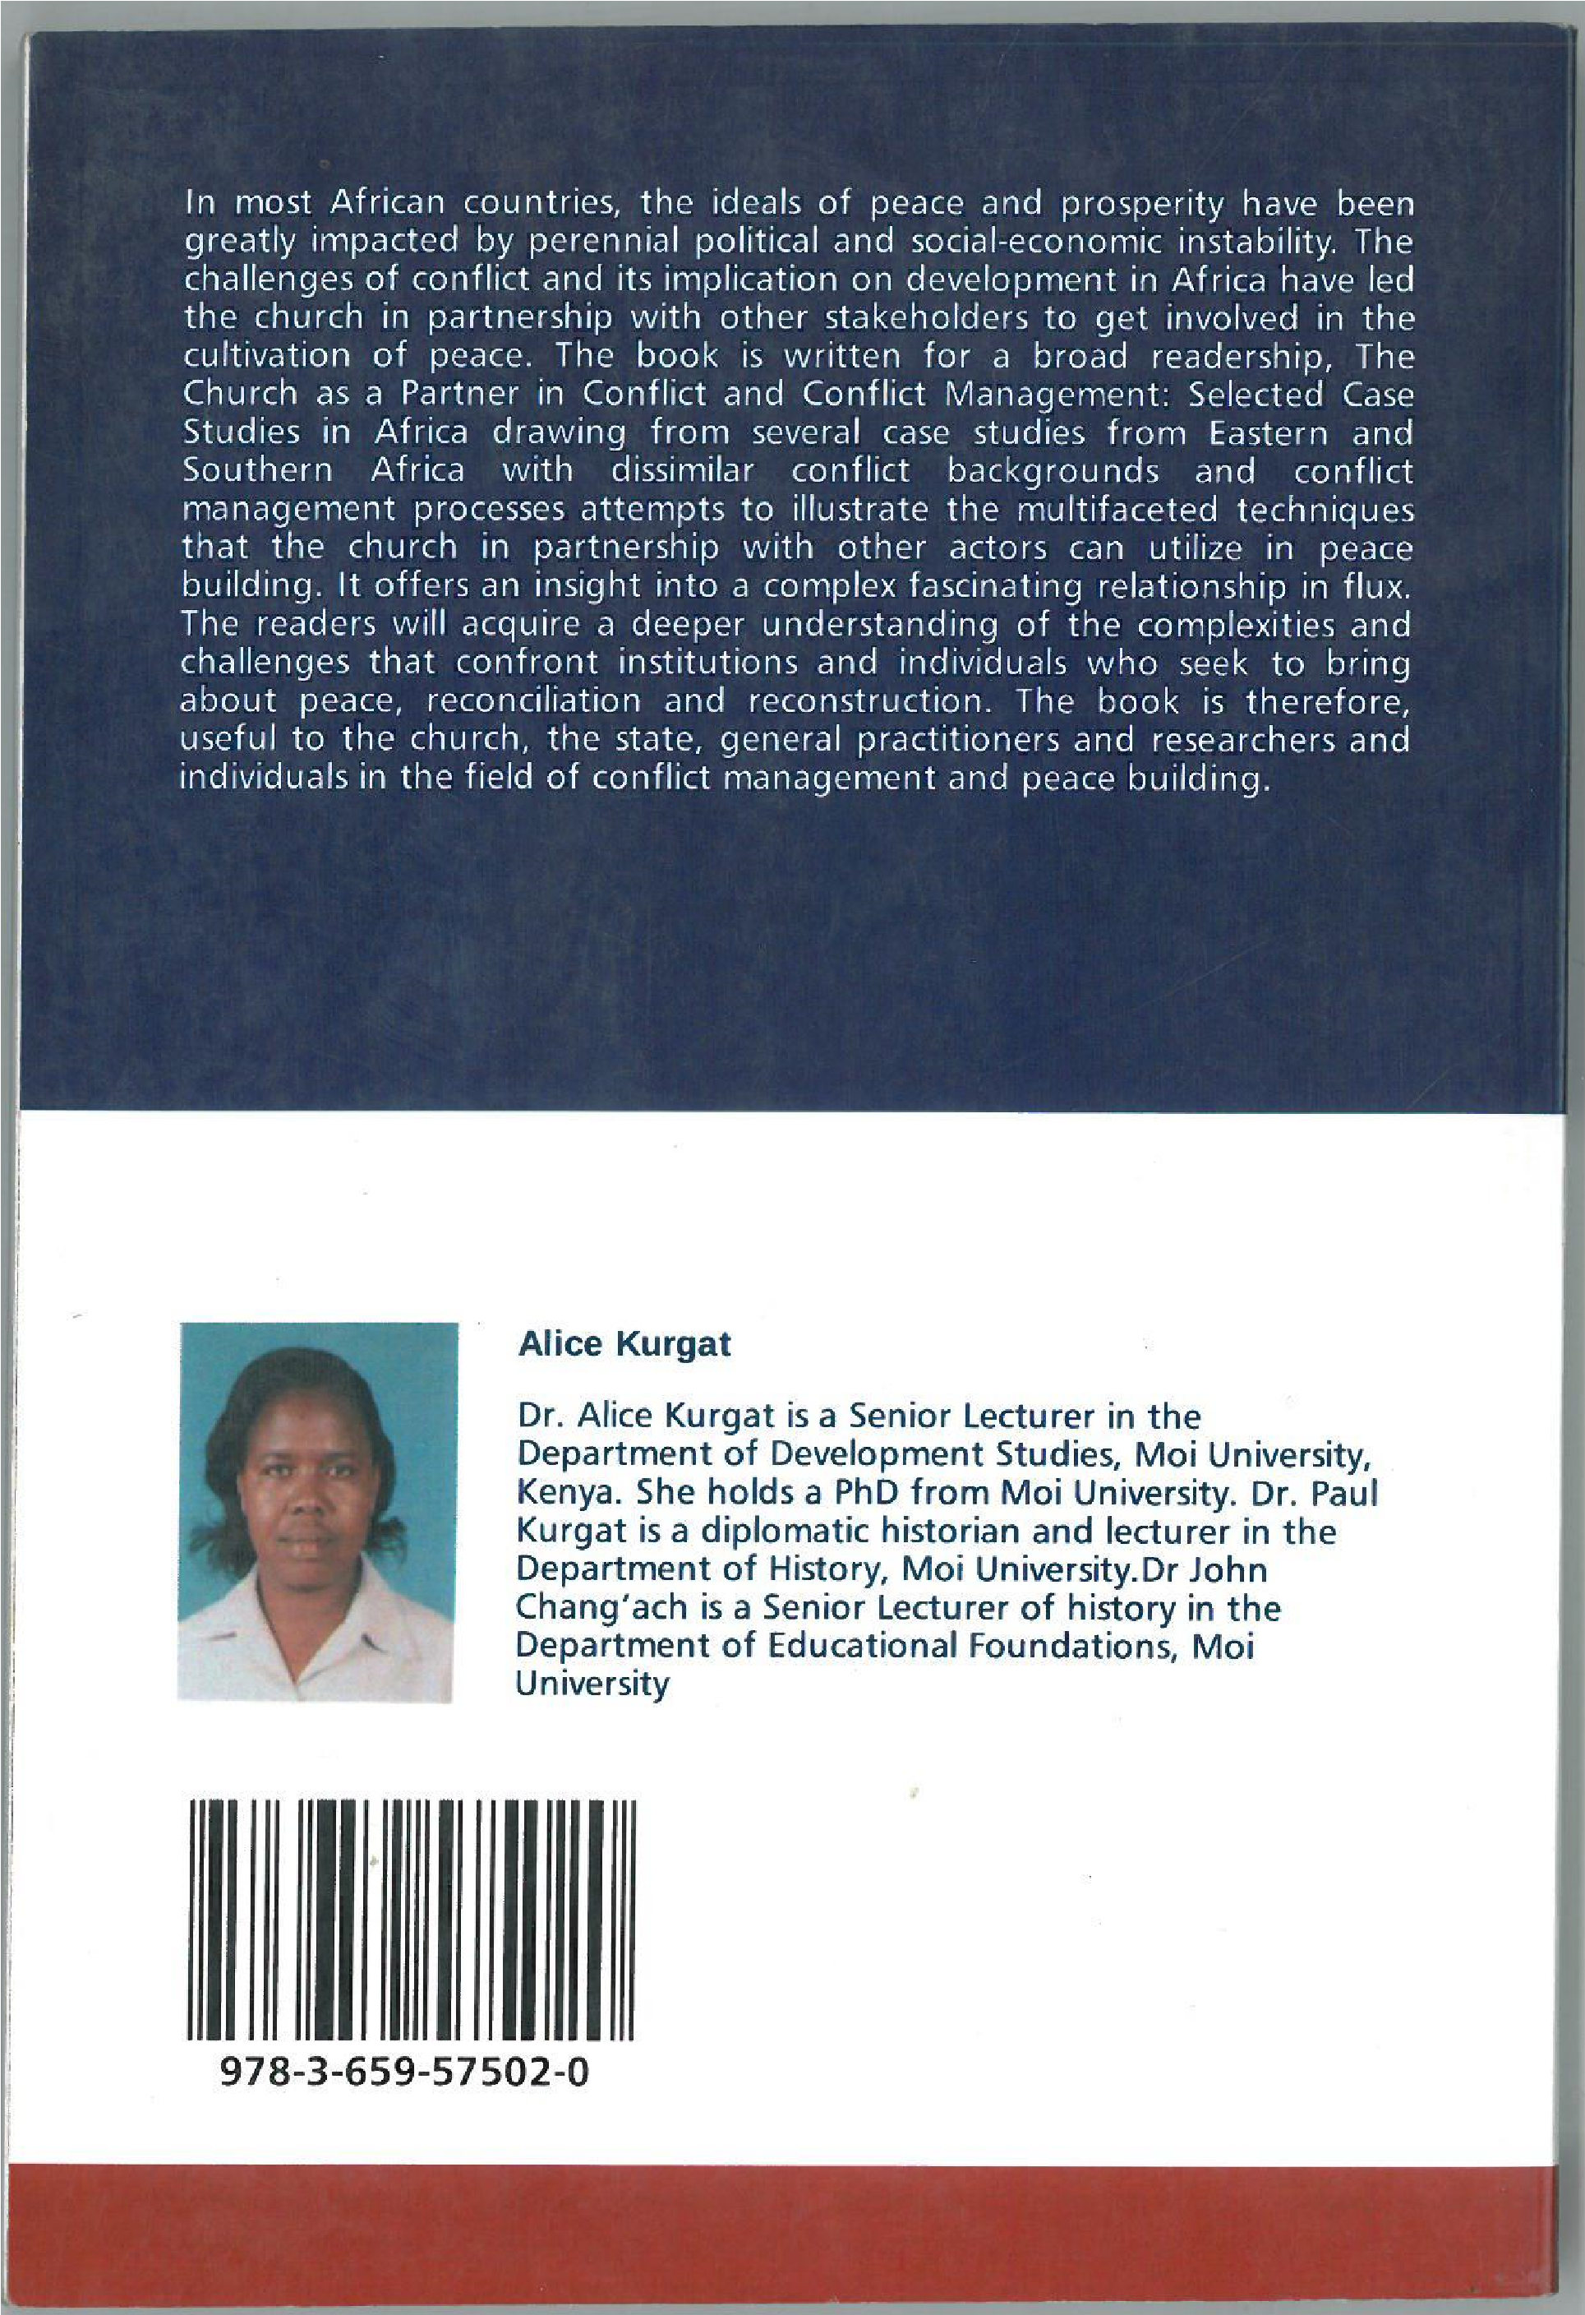

Source: Kurgat, A., Changach, J, Kurgat, P. (2014). The church as a partner in conflict management. Case Studies in Africa. Saarbrucken: Lambert Academic Publishing.

