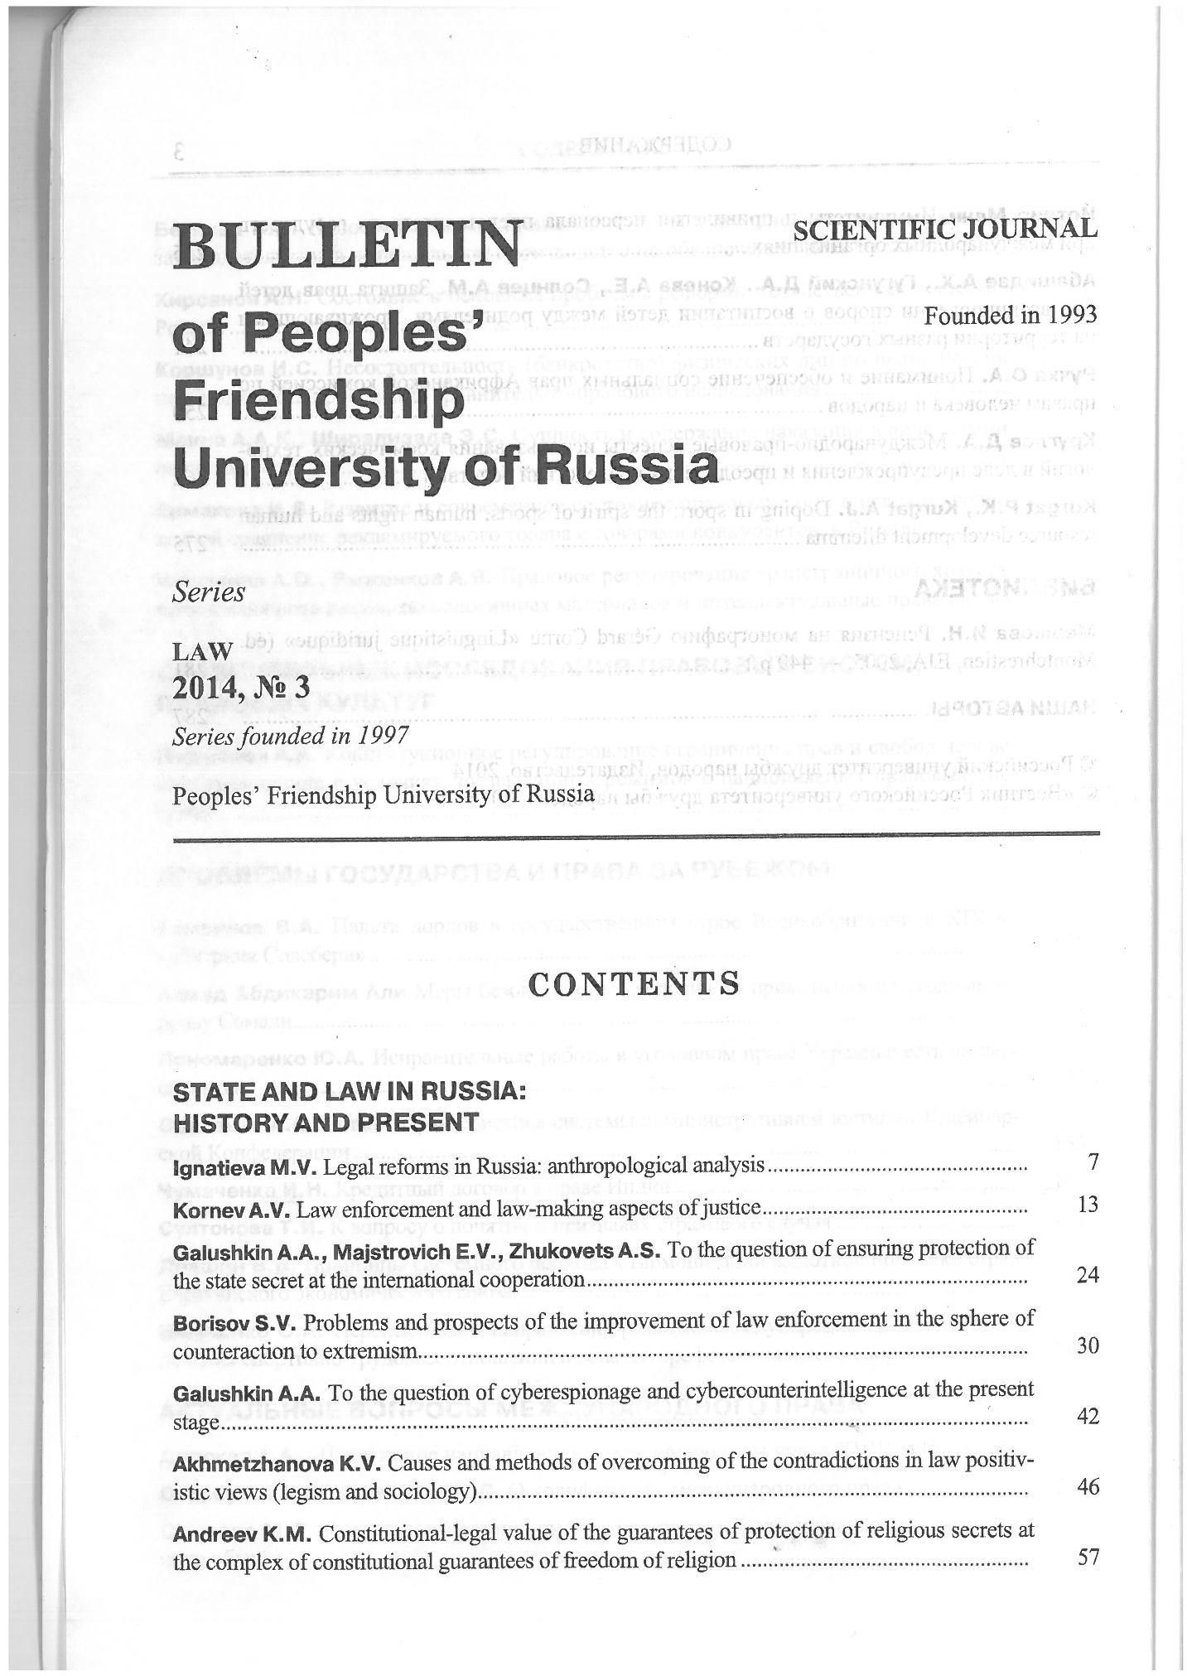
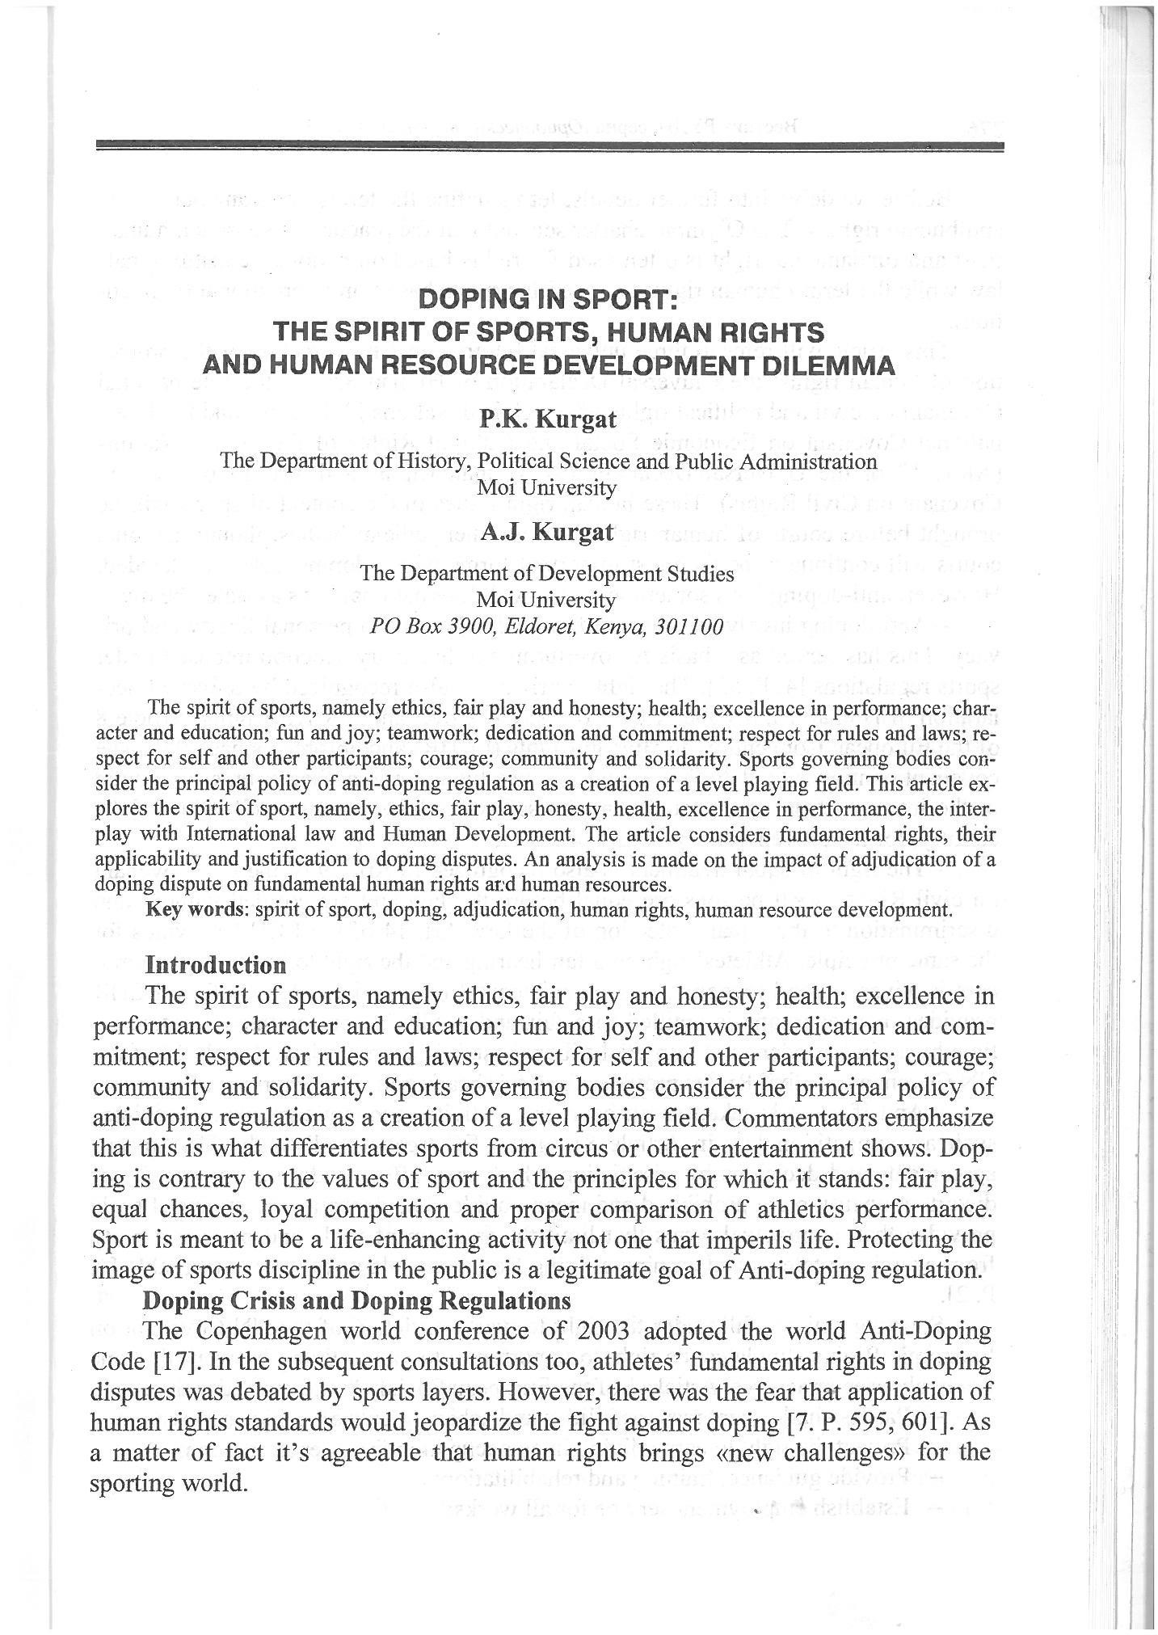
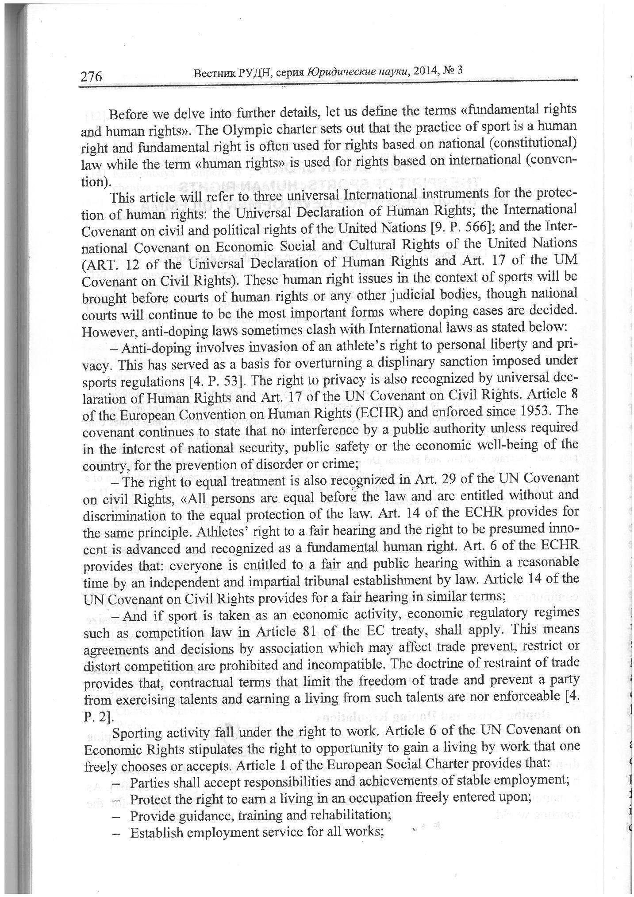
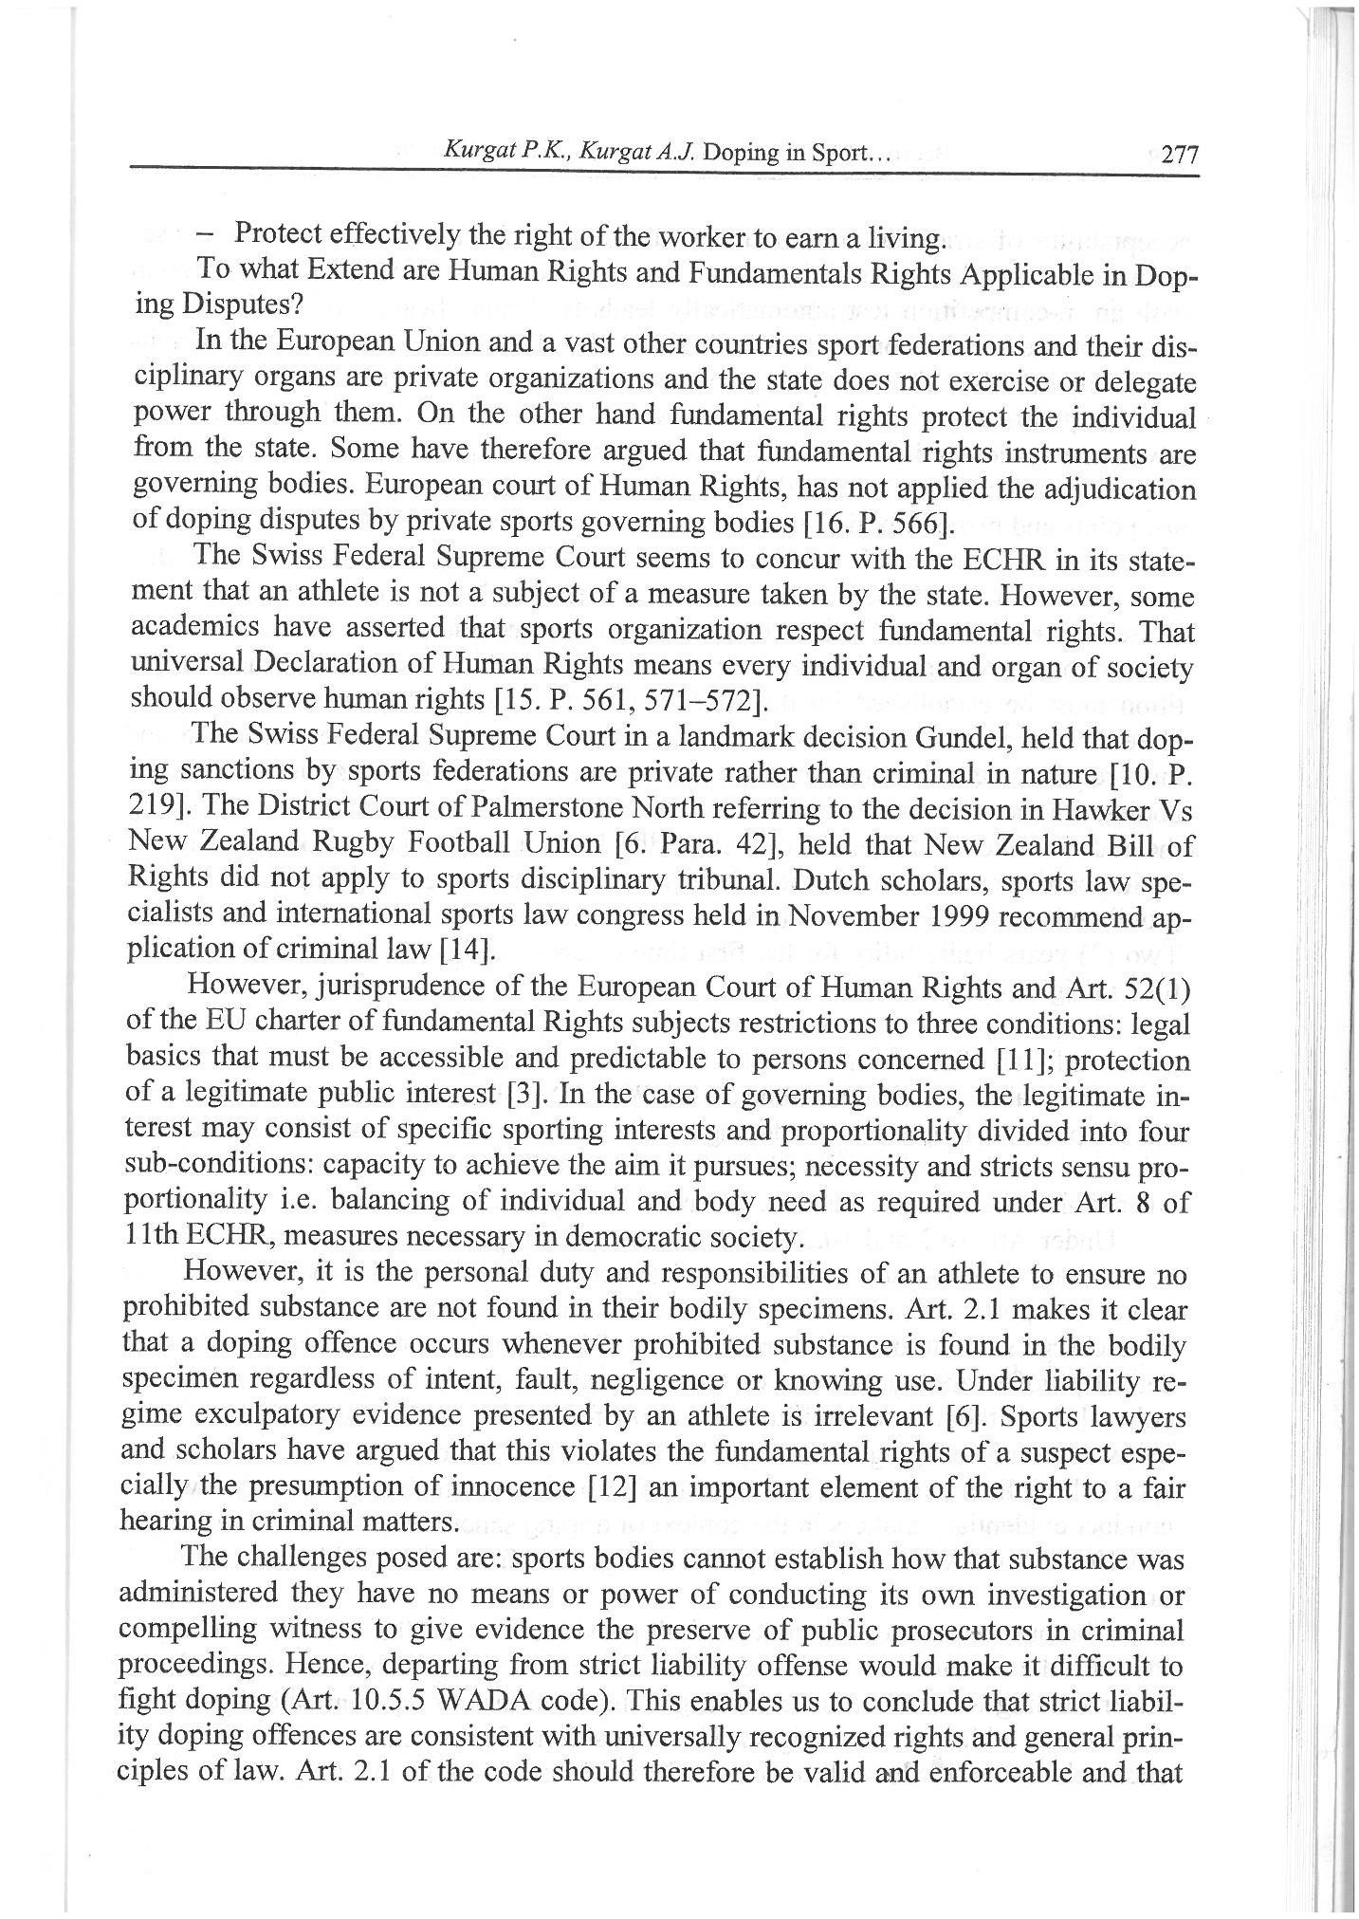
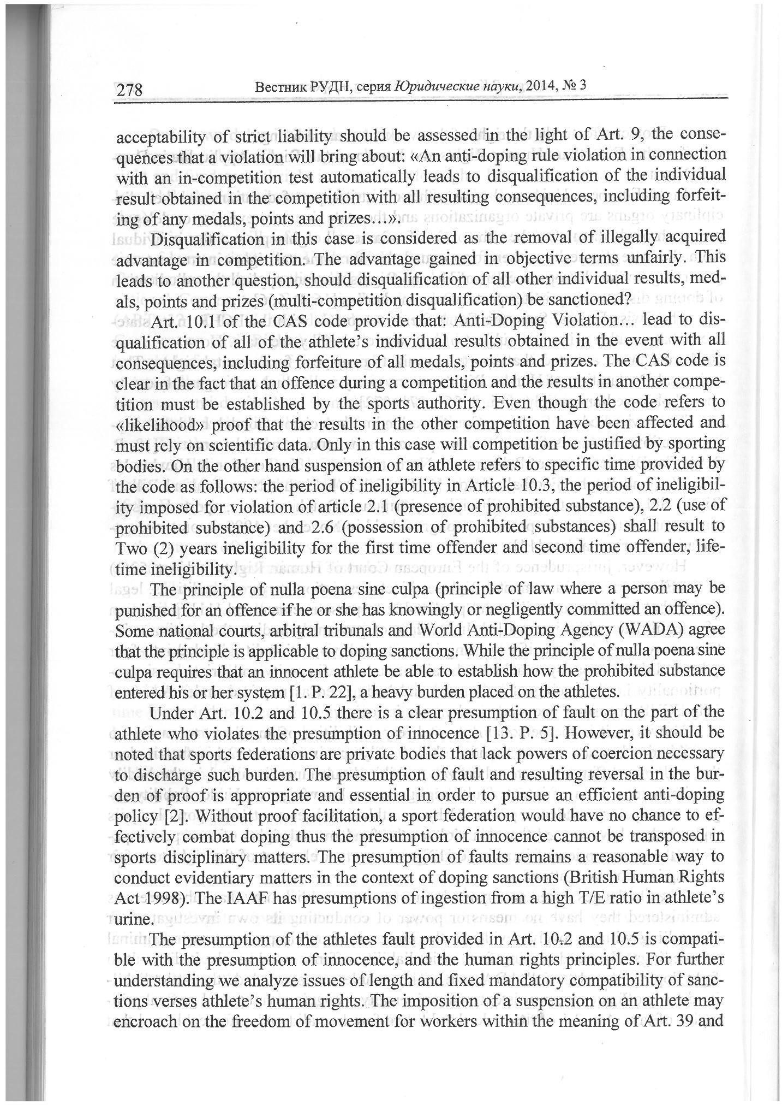

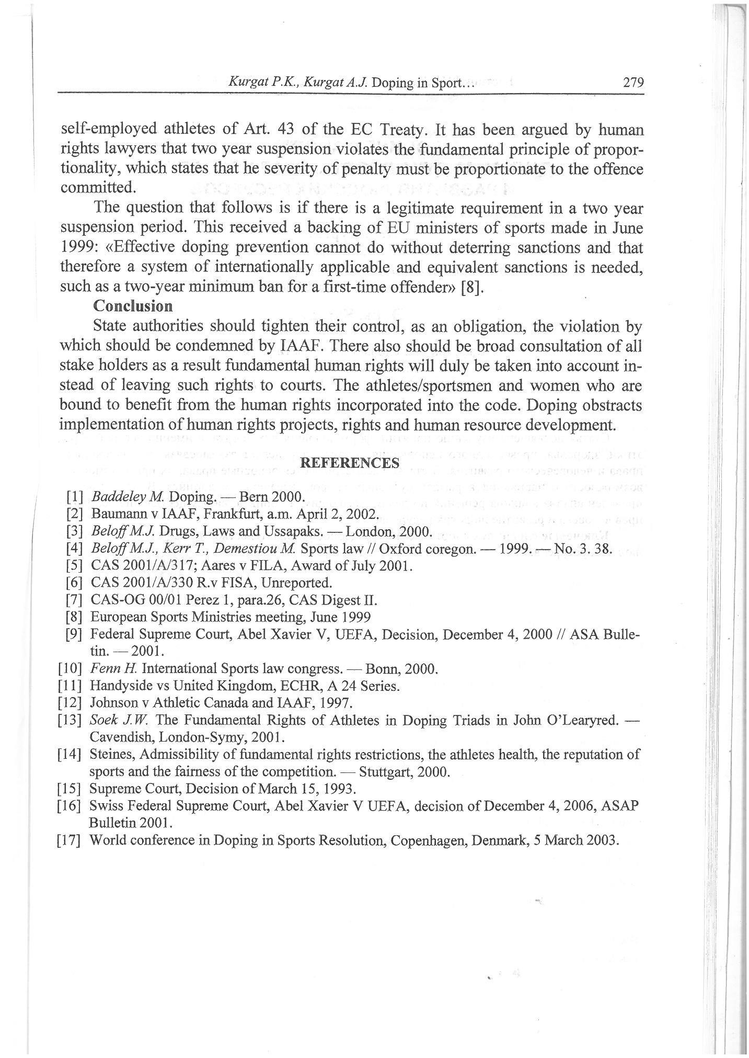

Source: Kurgat, P. K and Kurgat, A. J (2014). Doping in Sport: The Spirit of Sports, Human Rights and Human Resource Development Dilemma. Vestnik Scientific Journal, No. 3 ISSN 2213 - 2337. http://193.232.218.56/web-local/fak/rj/index.php?id=23&p=150

